

**GRADUATE CERTIFICATE**

**INTELLIGENT REASONING SYSTEM (IRS)**

**Project Report**

**For**

**Dog Breed Detective**

**Group Member**

**Tan Chee Wei (A0230818H)**

**Aloysius Ong Jun Long (S****702J)**

**Goh Zhi Hui (A0269364R)**

**Chen Yihan Johaness (A0214926A)**

Contents

1. Executive Summary 5

2. Problem and Business Considerations 6

2.1 Problem statement 6

2.2 Business Cases and applications 6

2.2.1 Manpower Shortage 7

2.2.2 Training Cost 7

2.2.3 Availability 7

3. Design of System 7

3.1 Proposed Solution 7

3.2 Conceptual 8

3.3 Architecture 9

3.3.1 Application Tier 10

3.3.2 Data Tier 10

3.4 Frame Diagram 10

4. Data 11

4.1 Data Collection and Assembly 11

4.2 Data Pre-processing for Image Recognition Sub-System 12

4.2.1 Data Cleaning 13

4.2.2 Data Integration 13

4.2.3 Data Transformation 13

4.3 Data Web Scraping & Processing for Dog Recommender Sub-System 15

4.3.1 Data transformation done on the scraped data 15

4.3.2 Derived average values for dogs’ height, weight and lifespan fields. 16

4.3.3 Data normalization 16

5. Flow Diagram 17

6. Modelling 18

6.1 Image Recognition 18

6.2 Modelling Algorithms used for Image Recognition Sub-System 21

6.2.1 Convolutional Neural Network 21

6.2.2 K Nearest Neighbour Algorithm 27

6.2.3 Decision Trees 30

6.3 Model Evaluation : Choosing CNN algorithm 32

6.4 Modelling Algorithm for Recommender System 32

6.4.1 One-Hot Encoding & Min-Max Scaling 33

6.4.2 Cosine Similarity 34

6.4.3 Euclidean Distance Similarity 34

6.5 Model Evaluation: Choosing Euclidean Distance 35

7. Testing and Evaluation 36

7.1 System Integration Testing 36

7.2 User Acceptance Testing 36

7.3 Evaluation 36

7.3.1 System Integration Test 36

7.3.2 User Acceptance Test 36

8. Promising Prospect, Current Shortcomings and Business Model 37

8.1 Current Shortcomings 37

8.1.1 Lack of Data Set 37

8.1.2 Recognition for hybrid dog breed 37

8.2 Promising Prospect 37

8.2.1 Expanding the range of pets 37

8.2.2 Chat bot 38

8.2.3 Pet Related Marketplace 38

8.2.4 Dog Illness Symptom Recognizer 38

8.2.5 Deciphering Dog Emotions 38

8.3 Business Model 38

8.3.1 Free Model 38

8.3.2 Premium Model 38

9. Conclusion 39

10. Appendix 40

10.1 References 40

10.2 Project Proposal 41

10.3 Project Objectives 50

10.4 Installation Guide 51

10.5 User Guide 55

10.5.1 Without Recommendation 55

10.5.2 With Recommendation 58

10.6 UAT Test Results 64

10.6.1 Goh Zhi Hui 64

10.6.2 Aloysius 65

10.6.3 Tan Chee Wei 66

10.6.4 Chen Yihan Johaness 67

10.7 Team Member Reports 68

10.7.1 Goh Zhi Hui 68

10.7.2 Aloysius Ong Jun Long 69

10.7.3 Chen Yihan Johaness 70

10.7.4 Tan Chee Wei 71

# Executive Summary

COVID-19 pandemic has created massive disruptions to businesses around the world and businesses are forced to take an aggressive stance toward reducing operation overheads and increasing their profitability in order to survive. However, the pandemic has not only brought about lower profitability, but it has also increased the outflow of skilled professionals. The pet industry is no different from the rest of the business and has met with similar fate with the rest of the industry. As we emerge from the crisis, the pet industry is now seeking innovative solutions to enhance productivity and rebuild their operations for sustained growth and promote resiliency into their business.

Pet owners on the other end of the equation face the same issues of getting reliable information and products amid the pandemic as pet business faces the shortage of manpower and logistics constraints. This brought about an increase in cases of pets’ abandonment and disownment as pet owners feel the hassle of keeping their pets. It turns the enjoyment of owning a pet into a nightmare when pets’ owners struggle to provide daily care for their pets.

The project team understands these pain points and is promoting a web application to reduce the dependency on the skilled and experienced staff of the pet industry to provide sound advice to the pet owners while pet owners could readily find reliable information, they require despite the shortage of staff within the pet industry.

The first step of the solution to create a Minimum Viable Product (MVP) for the recognition of dog breed as the first iteration. This will enable the application to provide details of the dog which the owner requires. Once the recognition of the dog breed is complete, the solution will provide first a brief description of the dog so that the owner would understand more about the dog. Secondly, the solution will provide insights from an established source on the different aspects of the dog breed such as the activeness, health, maintenance cost etc.

This will provide prospective dog owners with information so that they know about the essential upkeep that comes along with the dog. This is to manage their expectation so that they could be well prepared if they would proceed to get the dog breed they have selected. The team hopes that in this case, this will reduce the number of disownments of pets as the owners are well-informed of their pet’s upkeep.

For seasoned dog owners, the team hopes to provide new insights based on the insights provided by the application as some of this information might be unknown to these seasoned dog owners. Moving forward, the project team also hopes to add in more functionalities for these seasoned dog owners such as pet product recommendation, illness symptoms identification to provide an all-rounded experience for these dog owners.

The team will be using the techniques and knowledge acquired from the Graduate Certificate in Intelligent Reasoning System to build the MVP. The team will be employing the techniques in designing the system using a Frame Based system approach. The team will then be implementing the CRISP-DM approach in building the image recognition and recommender model for this MVP. The approach will consist of the evaluation of the best model for the MVP. The team has concluded from the evaluation that the optimum algorithm is using the Convolutional Neural Network (CNN). This enables high accuracy to be attained by the system and meet the success factor identified by the project team.

The team will also be deploying a recommender system to recommend similar dog breeds to prospective dog owners. This recommender will be built by using the Euclidean similarity algorithm to match the dog breed which was uploaded by the prospective dog owner against a list of dog breeds with similar aspects on the daily upkeep.

The project team is confident that with this MVP, it will be able to provide the dog owners with the essential information they require and reduce the reliance on the experienced pet shop staff while the pet store owners will be able to achieve higher customer satisfaction and retention despite in the reduction of manpower due to the outflow of experience staff. This will create a win-win situation for users at both sides of the equation.

# Problem and Business Considerations

## Problem statement

In the wake of the COVID 19 pandemic, there has been a continuous outflow of skilled professionals in the pet industry (Jong Ching Yee, 2022) and the training of new staff will need time and effort to ensure they provide adequate advice to prospective or existing pet owners. As a result, pet owners find it hard to find a single source of truth for their questions or assistance due to the lack of manpower in the pet industry.

Based on an article in Today Online, a survey was conducted with 1081 pets’ owners in Singapore with 30 percent of the pets acquired during the pandemics and almost 50 percent being first time pet owners.

As the demand for pets has increased dramatically during the pandemic, it is of utmost importance for the staff to provide sound and professional recommendations to reduce the implications caused by pets’ abandonment and disownment.

With adequate advice and recommendations, new or existing pets’ owners will understand the challenges of keeping the pets of their choice such as limited socialization opportunities, potential delays in veterinary care, and uncertainties surrounding future lockdowns and restrictions which will promote responsible pet ownership and welfare.

## Business Cases and applications

In an article (U.S. Department of Commerce, *Singapore Pet Products* 2021) from the U.S Department of Commerce, the Singapore Pet ownership has been in an uptrend for the past 5 years expanding at 3% yearly. The pet market is expected to reach a market value of $111.9 million in 2025 (Wang, 2022). Despite the increase in market value, constraints to businesses reduce the profitability to the industries. This provides business cases and applications to our proposed solution targeted to reduce the impacts from the following constraints and increasing profitability to the industry: -

### Manpower Shortage

The COVID-19 pandemic has had a significant impact on labour supply, with many workers being forced to stay at home due to illness or quarantine measures. Additionally, many businesses have had to scale back operations or shut down entirely, leading to reduced demand for labour.

The reduction in labour supply has led to several challenges for businesses, including increased costs for recruitment and retention of employees, as well as reduced productivity due to staffing shortages. As a result, businesses may experience a decline in profitability, as they struggle to maintain operations with fewer workers.

Moreover, COVID-19 safety protocols and regulations have also affected labour supply and profitability. Businesses have had to invest in protective equipment, sanitation measures, and other safety protocols to keep their workers and customers safe. These additional costs, coupled with reduced demand for labour and reduced productivity, may lead to a decline in profitability for businesses.

### Training Cost

Training programs can also take employees away from their regular duties, leading to reduced productivity and increased costs. For example, if employees need to attend a week-long training program, they may not be able to perform their regular duties during that time, leading to reduced output and potentially affecting the quality of the products or services that the business offers.

In addition, training programs may also lead to employee turnover. If employees feel that they are not being adequately compensated for their efforts, they may leave the company, leading to additional costs associated with recruiting and training new employees.

All these factors can lead to increased training costs and affect the profitability of businesses.

### Availability

As the system is available 24 hours a day via the internet, dog owners will not need to depend on the experienced pet shop helper or shop owners to provide sufficient information for their needs. This will bring about higher customer satisfaction from customers who are using this system from the pet business as they could get the information they need almost instantaneously.

Increase revenue and profit for the business as when the users search for recommendations, the system can recommend pets products which are suitable for the dogs they are checking with the system. This will bring about more sales opportunities and additional advertisement revenue from interested advertisers.

# Design of System

## Proposed Solution

Develop a web application that allows customers to upload images that have dog/s of their interest and be able to predict the breed of each dog and display the results to the customers. The results can be drilled down for each detected dog breed, retrieving additional information and characteristics of the dog breed.

The customers can review the information and better understand if the dog breed is what they are looking for.

Furthermore, the application will provide recommendations for customers for similar dog breeds and even allow personalization of the recommendation by taking in some facts of the customers and their preferences. This will ensure that the recommendations are relevant and as close to what the customers want.

## Conceptual

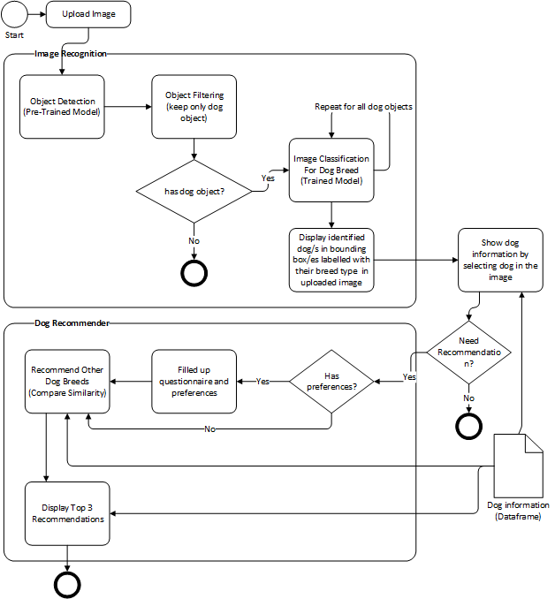

Figure 1

The application is made up of Image Recognition and Dog Recommender sub systems.

The Image Recognition sub-system is to process images uploaded by users to identify dogs in the image and to tag each dog with the predicted dog breed. Users will proceed to select the detected dog in the image to view details of the dog breed.

The Dog Recommender sub-system is to provide recommendations of other dog breeds that are similar to the dog of interest, and it has the option for users to fine tune the recommendation by providing some information about themselves.

There are 3 considerations to ensure that the application will perform up to standard.

1. Ability to detect dog in image.
2. Accuracy in predicting the dog breed.
3. Positivity of the recommendation

To address the 3 considerations, the application requires the following functions.

1. Object detection to detect objects in the image and the ability to differentiate the object by recognizing it as a dog or not a dog. There are existing pre-trained models that can achieve this, and we will evaluate and use the pre-trained model that is performing well.
2. Image classification to process the dog object and predict the breed of the dog as accurately as possible. There are various machine learning models to experiment, and we will use the same training and validation dataset to determine the best model for usage in the application.
3. Recommendation system to filter dog breeds based on customer information and to compare the dog breed with other dog breeds’ information to find the top 3 similar dog breeds for recommendation.

## Architecture

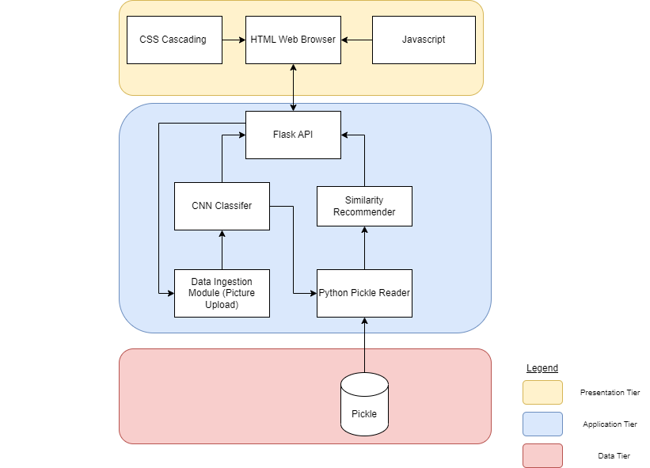

Figure 2Presentation Tier

The application is viewed through the web browser and the presentation layer is constructed from HTML, Javascript/AJAX and CSS. The application is designed as a single page application which eliminates page load when display is changed on screen. All data is fetched from the application tier through API calls and manipulated on the frontend HTML using Javascript.

### Application Tier

The application is deployed using Flask, a lightweight Python web framework that provides useful tools and features for creating web applications in the Python Language. The application basically serves as the backend for processing incoming API requests and returning the responses to the frontend.

All our programs are written in Python Language and using Flask naturally enables us to deploy the programs effortlessly. Another reason why we choose Flask is because it allows the application to be hosted locally.

### Data Tier

The permanent data we need for the application are information on the different dog breeds. The dataset is not humongous and is not subjected to change. Hence, using a relational database is not necessary as we can save the dataset into a pickle file that can be easily loaded in the backend when application is deployed and be utilized by the python program to search for the data and perform data manipulation on the fly.

## Frame Diagram

The project team is designing the system based on a frame-based system to enable the team to communicate better on the requirements of the Dog Breed Detective and provide better representations on the details which makes it more intuitive and readable. It also supports reasoning and inference which allows the team to retrieve and manipulate the knowledge based on the defined frame structure and the relationships between the frames.

The frame diagram below (Figure 3) is a representation of the design of the Dog Breed Detective. The frame enclosed with the solid lines are being developed within this iteration while the frames enclosed by the dotted lines are in plans for future development and implementation.

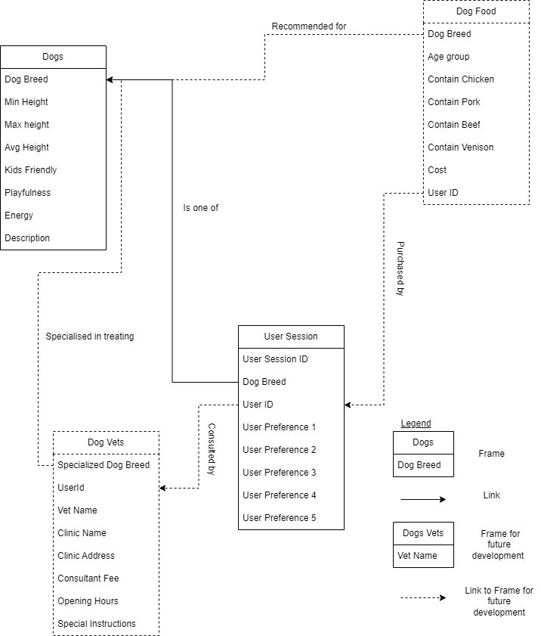

Figure 3

# Data

## Data Collection and Assembly

The dog image dataset is obtained from Kaggle, <https://www.kaggle.com/datasets/jessicali9530/stanford-dogs-dataset>. It consists of 120 categories of dog breed with a total of 20,580 images. Annotation information such as class label and bounding boxes is provided for each image.

## Data Pre-processing for Image Recognition Sub-System

By analysing the image dataset, the immediate observation is the images are colour images in various dimensions. The images contain non-dog objects and dog objects. The dog objects occupy a small area in the images.

Sample Images

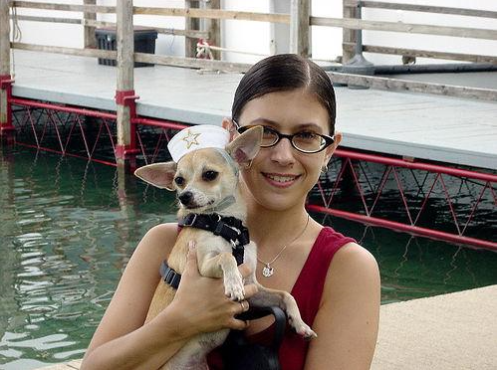 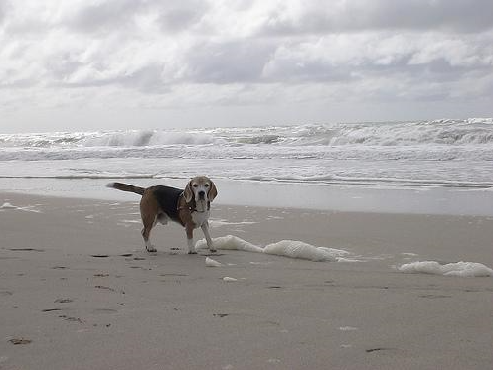

Figure 4 Figure 5

Based on the observation, we can say that the images contain large amounts of noisy data and applying machine learning algorithms on this data will not give quality results as it is hard to identify the pattern for each dog breed effectively. Therefore, we need to improve the overall data quality.

Next, we perform data analysis to understand the distribution of the dog breed.

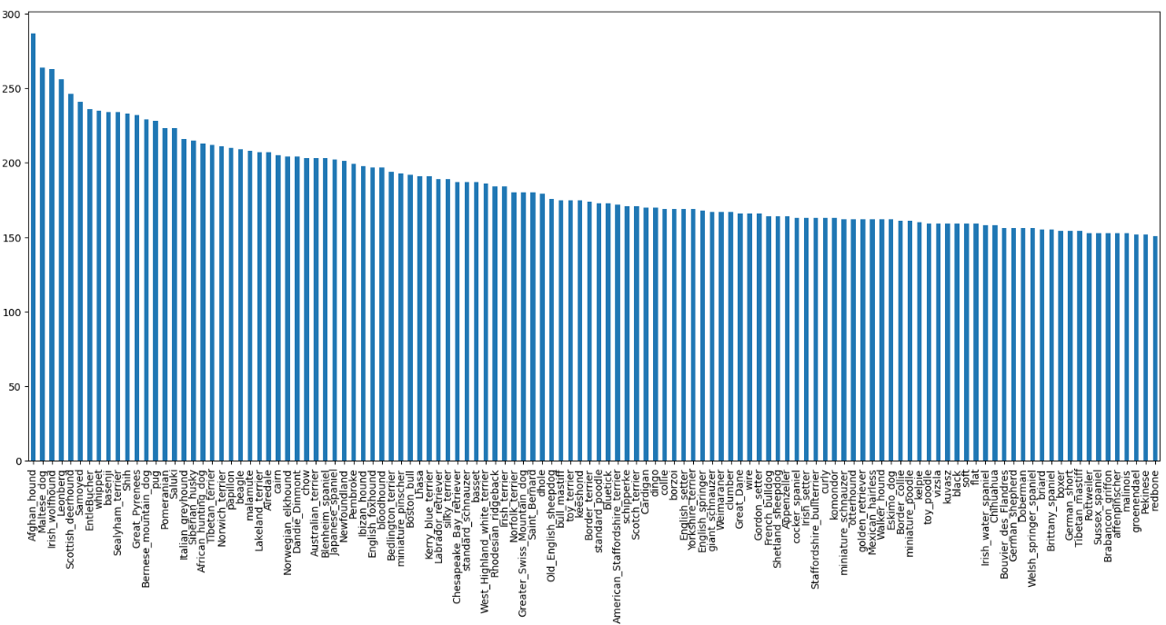

Figure 6

Based on the distribution, we can say that each class has about 150 to 200 images and there are only a few classes that have a very high number of images. The highest number is around 280 images. This indicates that the dataset is quite evenly distributed for each class which is a good sign as to avoid bias in training.

There are 4 steps (Baheti, 2021) in the data pre-processing listed as follows:-

### Data Cleaning

Data Cleaning is particularly done as part of data pre-processing to clean the data by filling missing values, smoothing the noisy data, resolving the inconsistency, and removing outliers.

The main problem identified is noisy data. To clean the data, we had to identify where the dog object is in the image so that we can crop out the dog object, removing all other noisy data. We make use of the image annotation’s bounding box coordinates to crop out the bounding box of a dog object and save it into a new image.

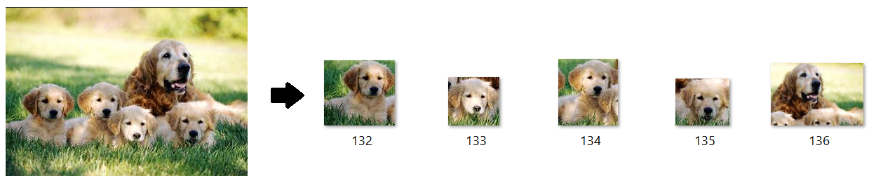

Figure 7

### Data Integration

Data Cleaning is one of the data pre-processing steps that are used to merge the data present in multiple sources into a single larger data store.

We recognized that we need to gather basic information on each dog breed so that we can use the information to recommend other dog breeds for our users. The gathering of dog breed information is a separate activity and the final data gathered has more dog breed classes then the 120 classes in the image dataset. We decided to retain all the information and integrate whatever classes that can be matched between the image dataset and dog breed information. Reason being that we have more dog breeds to recommend to users even if the training dog breed is limited to 120 classes.

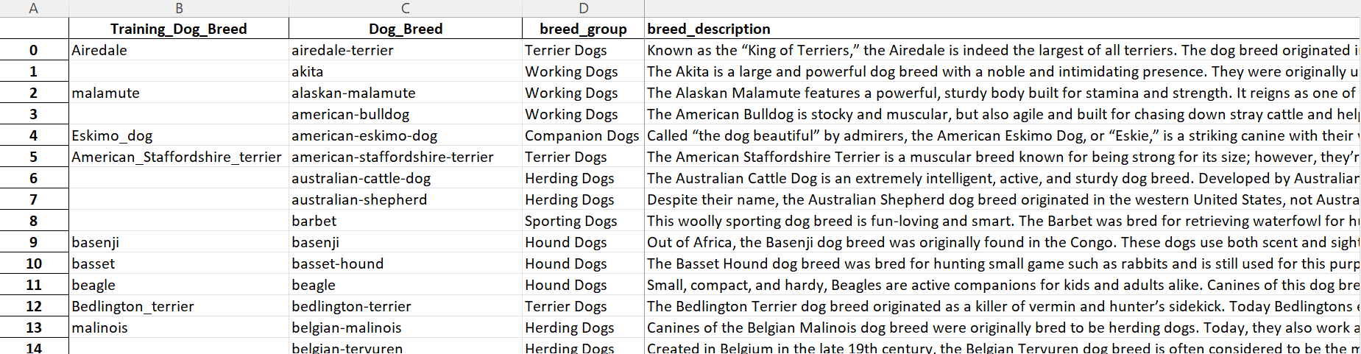

Figure 8

### Data Transformation

Data Transformation is to consolidate the quality data into alternative forms by changing the value, structure, or format of data. For transforming the unstructured data to structure data, we had to resize all the images to be of the same size.

To get a guideline on that image size to use, we performed data analysis on the image dataset to know the distribution of the image size.

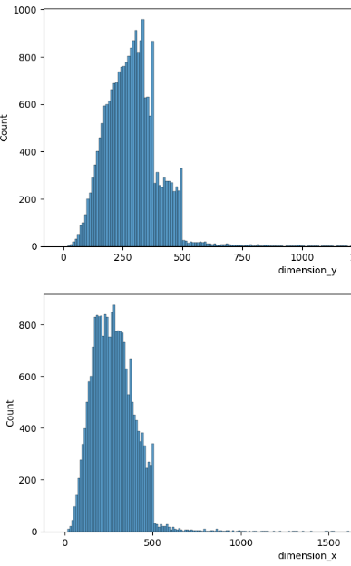 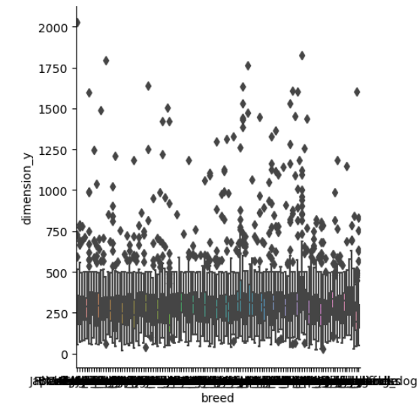

Figure 9 Figure 10

Majority of the images’ x and y dimensions are ranging from 150px to 400px. The most concentrated area is around 250px. Therefore, we decided to resize the images to 200px by 200px to be used in all our machine learning models.

Grayscale image is represented by width x height of the image whereas colour image is represented by width x height x 3 colours (Red, Green, Blue). Based on the machine learning model used we will use either greyscale or colour images accordingly.

Grayscale images are used for the following models because we believe the colour element will be negligible in the training and will help to reduce the training time:

* Random Forest
* Decision Tree
* Naive Bayes
* KNN

The above models expect a 2D array as input to the fit() function. The grayscale image of 200px by 200px is flattened into 1 x 40000px which are fitted to these models. After data flattening, we perform data normalization to maintain the pixels of the image within a uniform range. The pixel value is divided by 255 to change the range of a pixel from (0 to 255) to (0 to 1).

Colour images are used for the following model:

* Convolutional Neural Network (CNN)

The CNN model is more flexible and it allows us to define the input shape. ImageNet dataset primarily has natural images, where colour plays a semantic role. Using pre-trained models on ImageNet will imply that the input training dataset will preferably be in colour format so that extra information on the colour will improve the performance of the CNN training.

* Data Reduction is to obtain a reduced representation of the dataset that is much smaller in volume but produces the same quality of analytical results.

Colour image is composed of 3 layers of red, green, blue colour pixels which results in bigger data size, and it will increase the training resources required exponentially. As we have limited resources, we had to reduce data size to work within our resource limit. The method we applied is to convert the colour image to grayscale image which will greatly reduce the data size but still retain the integrity of the image.

## Data Web Scraping & Processing for Dog Recommender Sub-System

Web scraping is a technique of extracting data from websites by parsing the HTML code. In order to build the recommender system, we need to gather the dog breed profile data such as the breed description and characteristics rating. We utilized the BeautifulSoup & Requests library in Python to scrape data related to dog breeds from <https://barkingroyalty.com/> that provide information on different dog breeds and their characteristics. The scraped data contains attributes such as breed size, intelligence, maintenance level, energy level, temperament, and other relevant characteristics. The extracted data is processed and cleaned to remove duplicates, formatting text, and converting data types. The processed data is transformed & structured into a matrix format to be utilized in our content-based recommender system.

### Data transformation done on the scraped data

* One hot encoding on the breed group and dog size fields

Before:

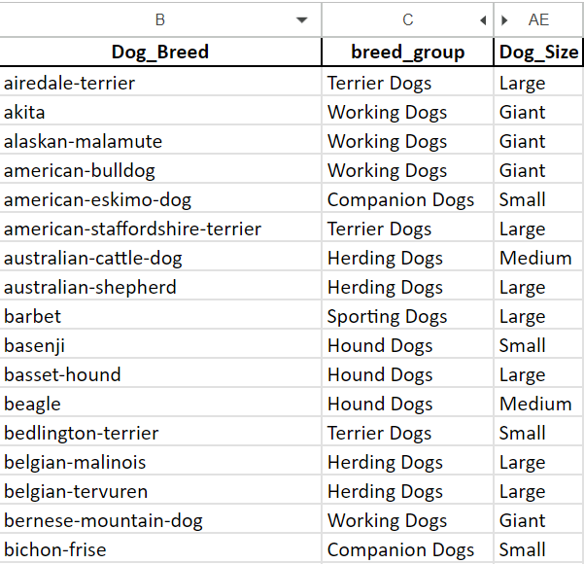

Figure 11

After:

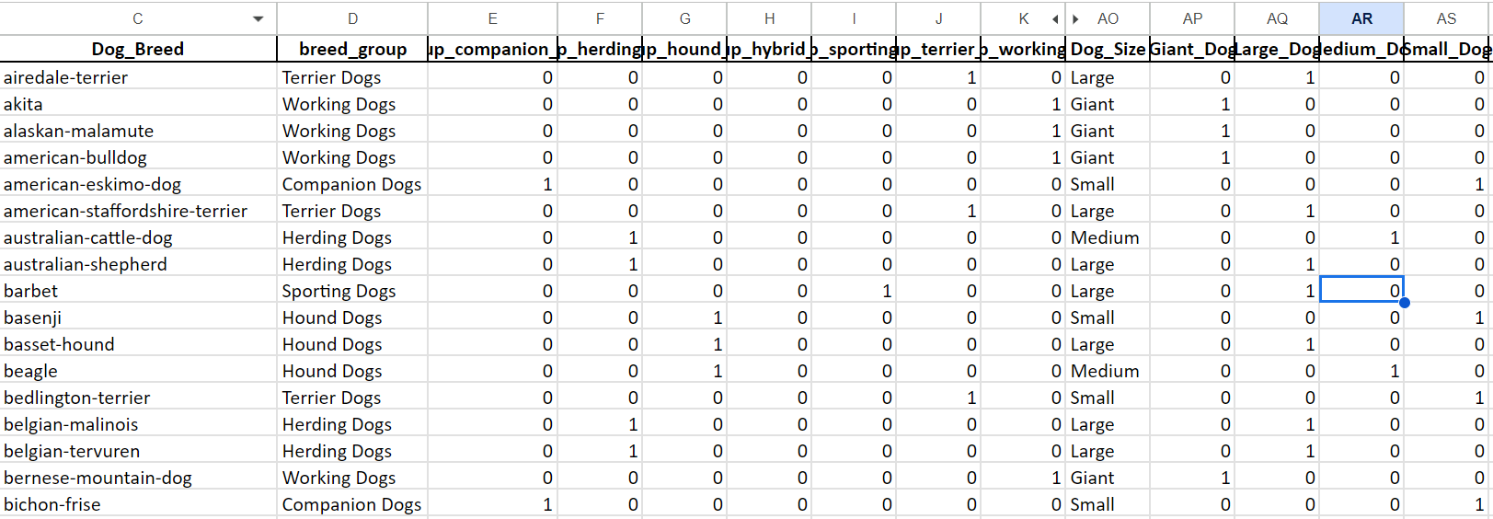

Figure 12

### Derived average values for dogs’ height, weight and lifespan fields.

Initially, the data we had is the minimum and maximum values for these fields. To maintain a consistent level of detail between the minimum and maximum values and improve the similarity check, we derive average fields to be used for the similarity check instead.

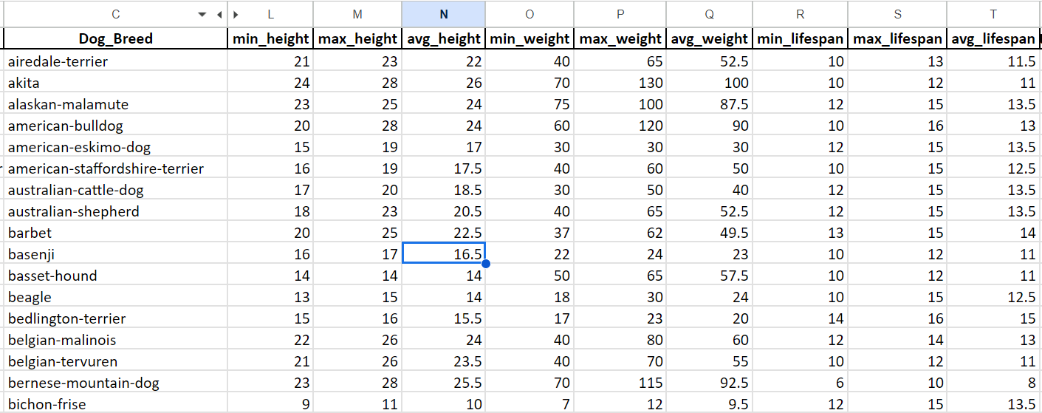

Figure 13

### Data normalization

Data normalization is not performed on stored data because we need to maintain the original values for displaying the dog’s information on the application. The normalization is performed on the fly in the backend recommender system before similarity check.

# Flow Diagram

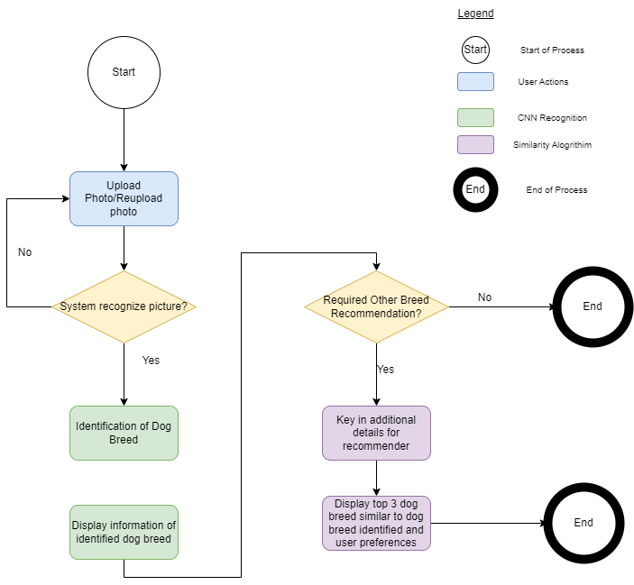

Figure 14

Dog Breed Detective enables the users to identify the dog breed by uploading a picture of the dog they want to identify. The picture could depict many objects in addition to the dog, the system will be able to recognise the dog from the rest of the objects. The above flow diagram(Figure 14) depicts the process flow for Dog Breed Detective.

# Modelling

## Image Recognition

Image recognition is a mechanism used to identify an object within an image and to classify it in a specific category, based on the way humans recognize objects within different sets of images.

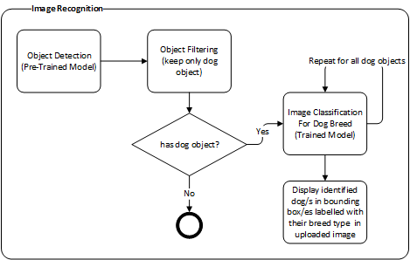

Figure 15

The image recognition sub-system requires 3 main functions.

1) **Object Detection:** Locate the presence of objects with a bounding box and types or classes of the located objects in an image. It is a mix of object localization and classification.

· Input: An image with one or more objects.

· Output: One or more bounding boxes (e.g. defined by a point, width, and height), and a class label for each bounding box.

To train a model to perform object detection is resource intensive and it requires extremely large training data which we do not have. As there are readily available pre-trained models that can be used for object detection with high accuracy in detecting dog objects, we decided to research for a suitable pre-trained model for implementing our object detection function.

Generally, there are 2 types of detector:

1) **Two-stage detector:** Where detection is complete in two steps, the first step uses regional design networks to create areas of interest with a high probability of being an object. The second step is object detection, which performs the final classification and regression of the bounding box of the objects. RCNN, Fast RCNN, SPPNET, Faster RCNN, etc., are some of the two-stage detectors.

2) **One-stage detector:** Where object detection is a simple regression problem that takes input and learns probability classes and bounding box coordinates. YOLO, YOLO v2, SSD, RetinaNet, etc., fall under one phase detector. Object detection is an advanced form of imaging classification where a neural network predicts objects in an image and draws attention to them in the form of bounding boxes.

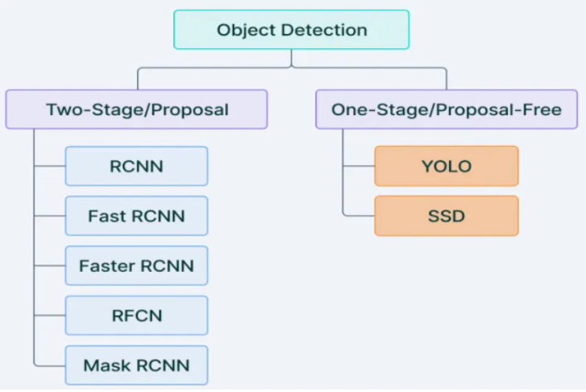

Figure 16. (N et al., *Object detection using Yolo and mobilenet SSD: A comparative study* 2022)

Online studies in general mentioned that one-stage detector is faster as compared to two-stage detector but the accuracy is slightly lower than two-stage detector. We selected the one-stage detector as response time is critical to the application. It provides us the probability classes of each object and its bounding box coordinates which meet our use case requirement.

“Mobilenet SSD is an object detection model that computes the output bounding box and object class from the input image. This Single Shot Detector (SSD) object detection model uses Mobilenet as a backbone and can achieve fast object detection optimized for mobile devices. This network is suitable for real-time applications because it does not resample functions for bounding box hypotheses.”

We employed the Mobilenet SSD model as the TensorFlow object detection model. Using TensorFlow API as the engine in the object detection function. The function is tested with images composed of different objects and the results are satisfactory.

Sample test case 1: Dog with similar looking animal

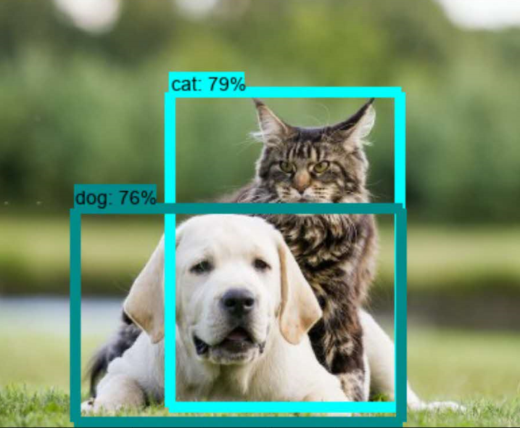

Figure 17

Sample test case 2: Multiple dogs

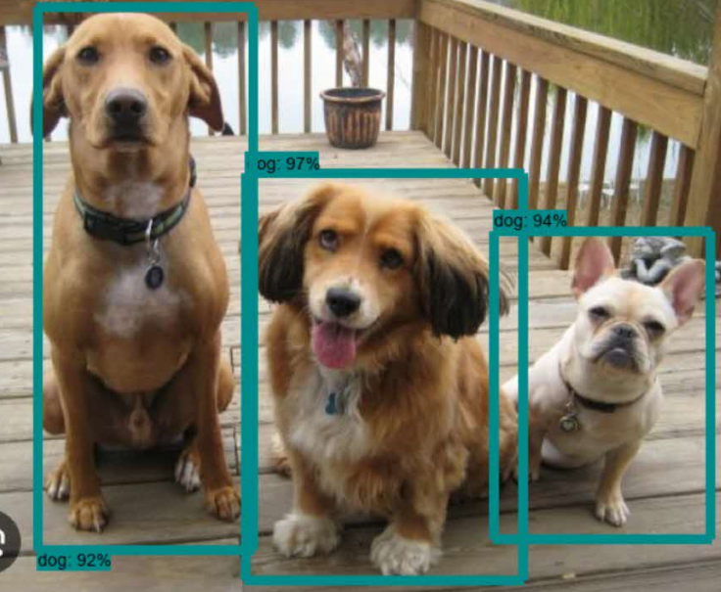

Figure 18

2) **Object Filtering:** Locate the presence of dog objects and retain the bounding boxes in an image. All other types or classes of located objects are removed.

· Input: One or more bounding boxes from object detection function.

· Output: One or more bounding boxes of dog objects.

The filtering is to remove bounding boxes for non-dog classes by checking the class label and removing them from the list. The second criteria is to use a suitable threshold to remove dog objects with predicted score < 50% so as to reduce false positive cases (objects that might not be a dog but tagged as a dog class).

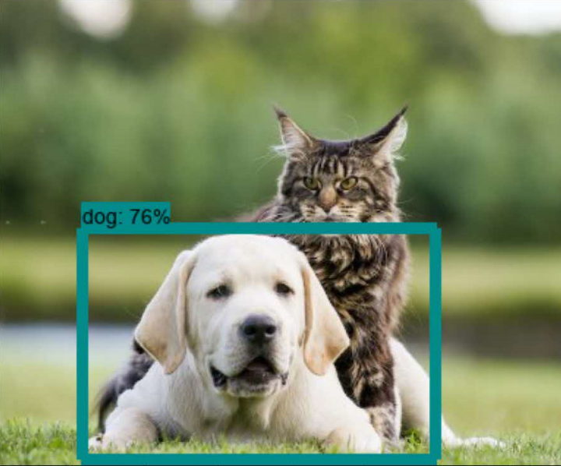

Figure 19

3) **Image Classification:** Predict the type or class of an object in an image.

· Input: An image with a single object.

· Output: A class label (e.g. one or more integers that are mapped to class labels).

Each bounding box is cropped as an image and passed into the image classification function for prediction of the dog breed. We utilized a transfer learning technique to extract features in the image using pre-trained CNN models.

We build a model to take in the extracted features to predict the probabilities of the features for each of the 120 dog breed classes. We will take the highest scoring breed class and label the dog object with the breed name.

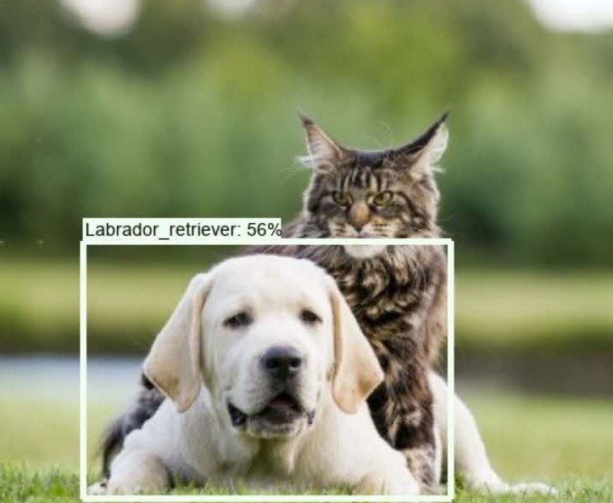

Figure 20

More explanation on why we utilized feature extraction and the machine learning techniques to classify dogs into the 120 dog breed classes in the CNN section below.

## Modelling Algorithms used for Image Recognition Sub-System

### Convolutional Neural Network

The advancements in Computer Vision with Deep Learning have been constructed and perfected with time, primarily over one particular algorithm — a Convolutional Neural Network (CNN).

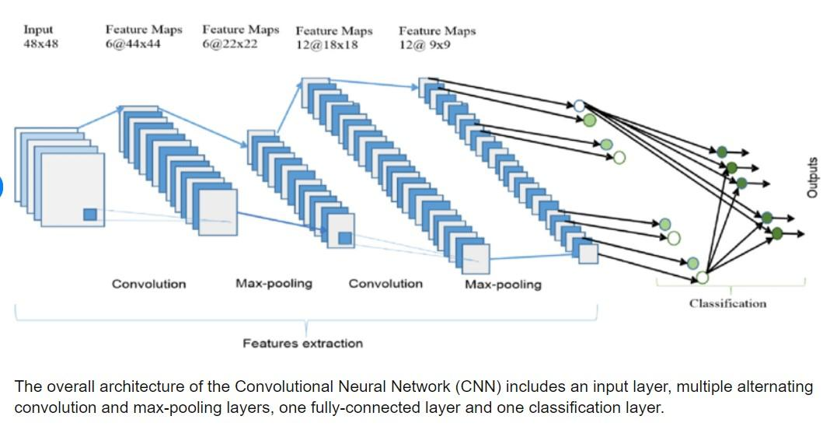

Figure 21

Technical explanations of CNN:

* CNN consists of a convolution layer, a pooling layer and a fully connected layer.
* The convolution layer reduces the dimensionality of the image by determining how large the partial images should be and how many pixels are between calculations.
* The pooling layer then takes the average or maximum value from the result depending on the application, preserving small features in a few pixels that are crucial for the task solution.
* Lastly, the fully connected layer consists of tightly meshed layers to link the sub images and carry out the classification.

It is a proven algorithm which we will not go in-depth, but we will explain some experiments we have done with different CNN architectures and the results which lead to the usage of transfer learning and feature extraction techniques.

The very first experiment we did is to train a CNN classification model from scratch.

We use a basic CNN design following the flow below:

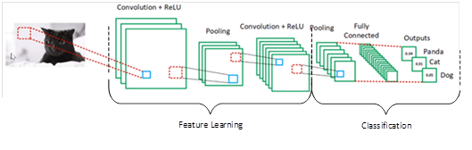

Figure 22

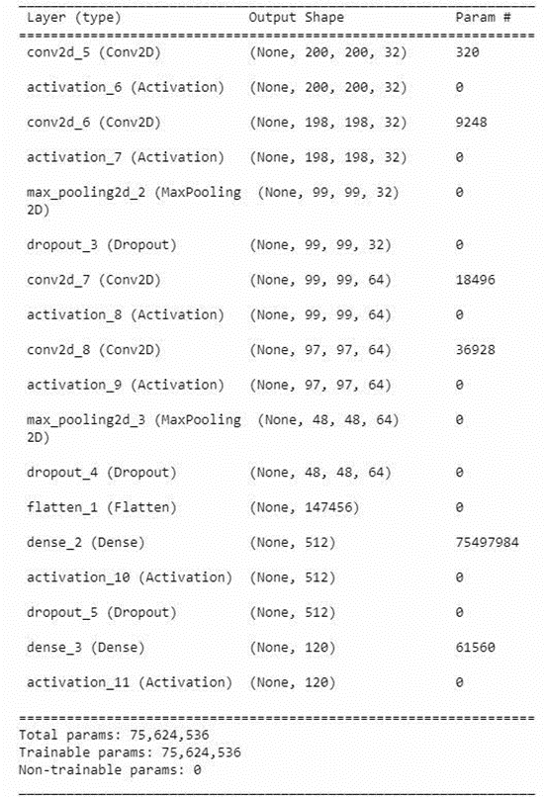

Figure 23

As the training images are of size 200px by 200px, the number of trainable params is huge. In order to speed up the training to have a gauge on the performance, we decided to use grayscale images instead to reduce the trainable params.

We trained the dataset for 5 epochs and the results are extremely poor as shown below.

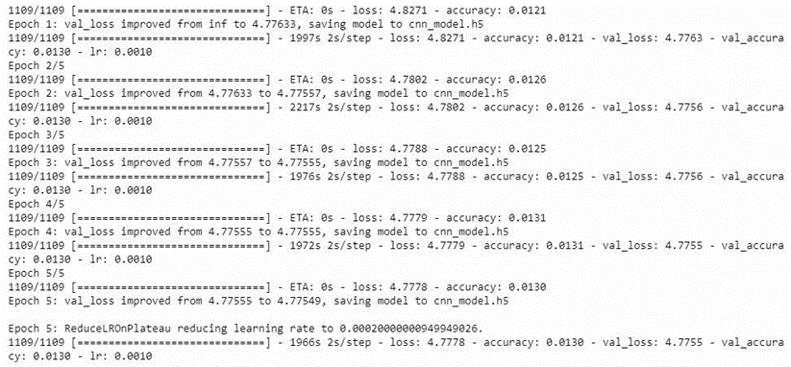

As we do not have the luxury of time, we decided not to continue with this design as the primary result proved to be inefficient and ineffective. We started to look at some other famous CNN architectures such as LeNet and AlexNet instead. We constructed the CNN model following the design of LeNet below.

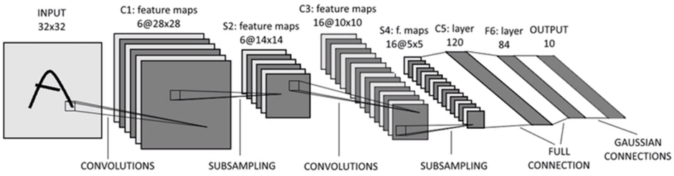

Figure 24

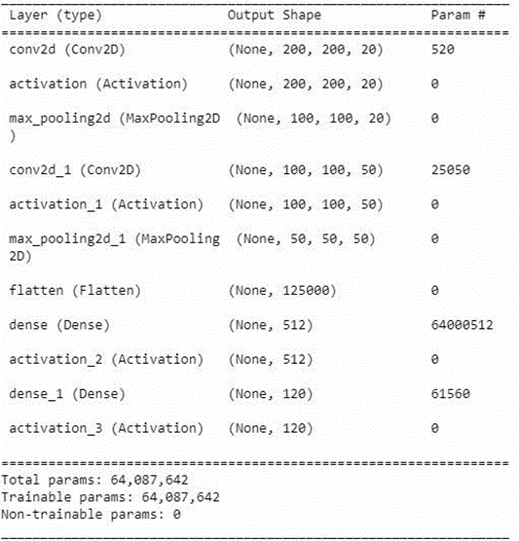

Figure 25

We did the training with the same dataset and set the max epoch to 100. The results are as below.

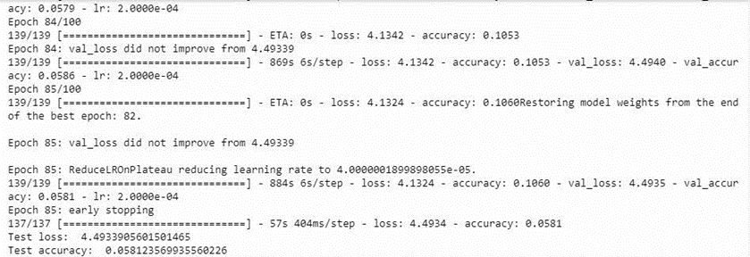

Figure 26

The result is far from satisfactory, obtaining around 10% accuracy. The training stopped at epoch 85 as the early stopping condition was met when the validation loss did not improve for 3 consecutive epochs.

It is not easy for the model to train and classify 120 dog breeds especially when each dog breed has a very small number of training images, average around 150 images. Realising that, we explored the technique of using data argumentation to boost up the training images by adding variations such as rotations, shifts, zooming etc, making the classifier much more invariant to changes in our images. Thus, making it far more robust and reducing overfitting due to the increased variety in the training dataset.

We utilized Keras’ built-in data augmentation API to perform just-in-time augmented image dataset i.e. generating the augmented dataset during the training process.

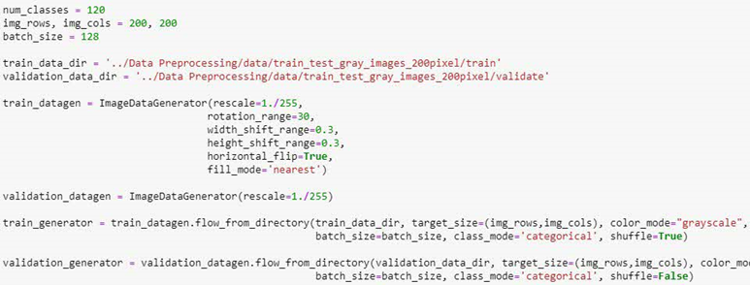

Figure 27

We run the training again with the data augmentation and the result is as below.

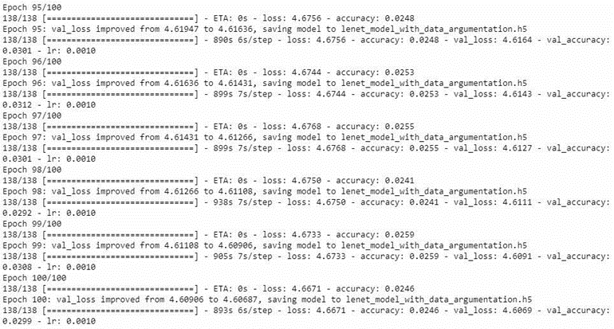

Figure 28

The training managed to complete the 100 epochs but the accuracy dropped and overall the result is disappointing.

We then explored AlexNet. This architecture is said to produce better results in classification but the downside is that it is a very deep CNN and training needs an extremely huge amount of resources. The constructed model has a total of 736,789,353 trainable params.

We tried to run for 1 epoch and the estimated time to complete is 22 hours. Taking into consideration the amount of time we need to complete even a reasonable number of epochs, we decided to abandon this model.

Training a CNN model from scratch proved to be complicated and slow. The training dataset is also a major factor in determining the success of the training. Typically, we will have to have a very sizable training dataset.

We had no other option but to leverage on trained models that are available for us to reuse for our own classifier. These trained models have weights that are already tuned to detect thousands of low/mid/high level features. This technique is called transfer learning - “Transfer learning and domain adaptation refer to the situation where what has been learned in one setting … is exploited to improve generalization in another setting”.

In basic the following steps are used to implement transfer learning.

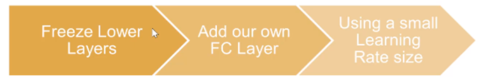

Figure 29

1) We freeze the already pre-trained lower convolution layers as they are well trained to capture universal type features (curves, edges, blobs).

2) We replace the top fully connected layer with our own, mainly because we are training to fit a different number of classes of 120 dog breeds.

3) Using a small learning rate helps us avoid distorting the newly initialized weights to quickly generalize.

We choose to use the ResNet50 model from TensorFlow Keras API to experiment on the transfer learning technique. The result did not improve much, the loss is still high and accuracy is low.

Next we came across a strategy online on feature extraction. Following are the steps to implement feature extraction.

1) Create a feature extractor model using different pre-trained CNN models. ResNet50, DenseNet and NASNetMobile models that are trained on “imagenet” are used to merge into a single model.

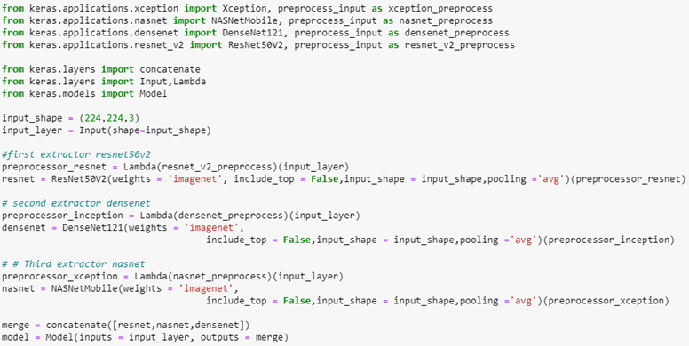

Figure 30

2) The single model is used for processing the image raw data to extract the features and stack the features together.

3) Use a simple deep neural network with one dense layer and a heavy dropout layer to figure out patterns in the features extracted from the data and train to classify images to the 120 dog breed classes.

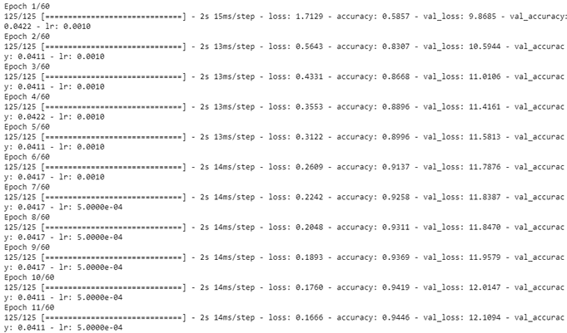

Figure 31

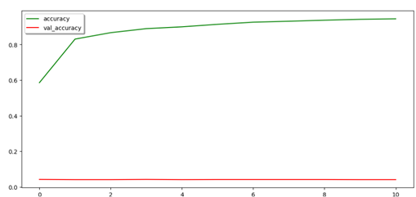

Figure 32

This result is the best so far. It took less than a few seconds and the training ended at the 11th epoch with an 94% accuracy. Hence, we are satisfied with that and decided to select this model to be used in our image recognition sub-system for image classification.

### K Nearest Neighbour Algorithm

The k-nearest neighbour (k-NN) algorithm is a simple and intuitive machine learning technique used for classification and regression tasks. It's called "k-nearest neighbour" because it looks at the k closest neighbours to make predictions or decisions.

The project team has decided to test if this model is suitable for our project. Hence the project team begin to build the model from scratch. The first step will be data collection which we will be using the Stanford Dogs Dataset as mentioned in the Data section of this report.

Next, the project team makes use of the data which are pre-processed according to the data processing stages as mentioned Data Section and ingest it into the python notebook.

We have pre-split the images files to a train set and a test set as below (Figure 33):-

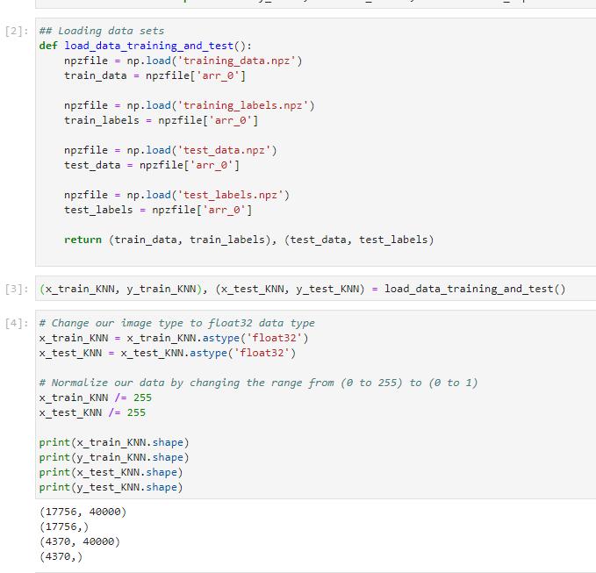

Figure 33

There are 17756 images in the train set and 4370 in the test set.

We then build the model using when k= 120 as we have 120 breeds in the dog dataset and see how the model fares under this parameter.

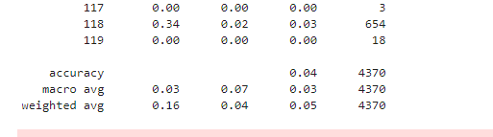

Figure 34

From the accuracy metrics, the accuracy is lesser than 0.05%. The team then start to try to hyper tune the parameters by running the below code to try to find the best K value for the model.

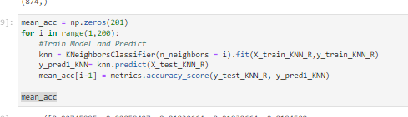

Figure 35

However, due to the size of the dataset, the above code require a sizable amount of resource to complete the code. In view of our time constraints, the project team decide to test using a reduce set to try to get the best K value first and see if there is any improvement to the accuracy.

The team decided to use the current test set of 4370 images and split this using the train/test split function.

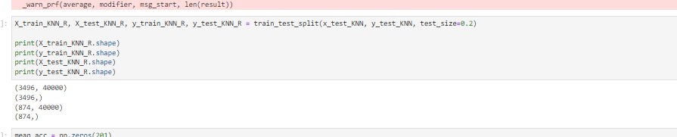

Figure 36

In this case, the train set is reduced to 3496 images while the test set is at 874 images.

The team then starts to try to hyper tune the parameters by running the hyper tuning code again on the reduced dataset to try to find the best K value for the model.

The values are then plotted to the chart and from the chart below, we can see that there is no significant increase in accuracy when we use any value of k from 1 to 200.

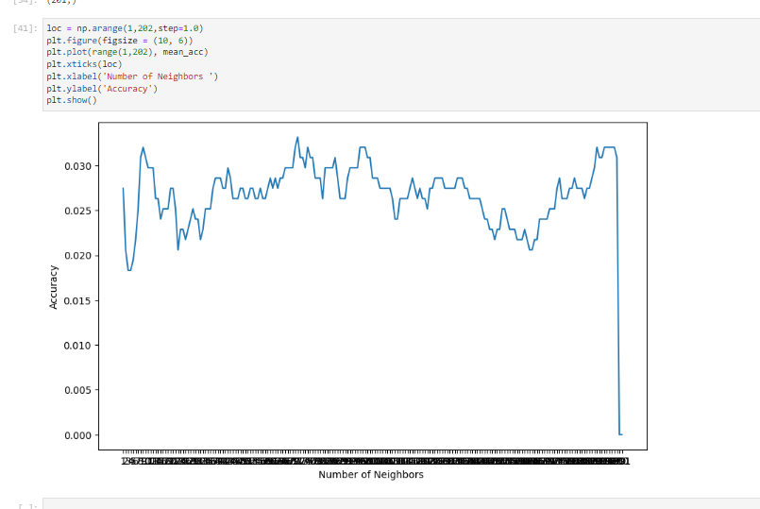

Figure 37

In view of this result, the team discussed and concurred that due to the constraints on time and resources, the team will proceed to prioritise our resources on other algorithms which might be more suitable for the recognition model.

### Decision Trees

The decision tree algorithm is a machine learning technique used for classification and regression tasks. It builds a tree-like model of decisions based on features or attributes of the data to make predictions or decisions.

The project team has shortlisted this model and will evaluate if this model is suitable for our project. Hence the project team began to build the model from scratch. The first step will be data collection which we will be using the Stanford Dogs Dataset as mentioned in the Data section of this report.

Next, the project team makes use of the data which are pre-processed according to the data processing stages as mentioned Data Section and ingest it into the python notebook.

However, as we understand that decision tree algorithms can grow large in size especially for datasets which are large in features which apply to our current dataset. The current datasets have a total of 40000 features which require a huge amount of resources and time.

Hence the project time decided to reduce the number of items in the test set to gauge the accuracy of the model before committing additional time and resources for this model. The team decided to use the current test set of 4370 images and split this using the train/test split function.

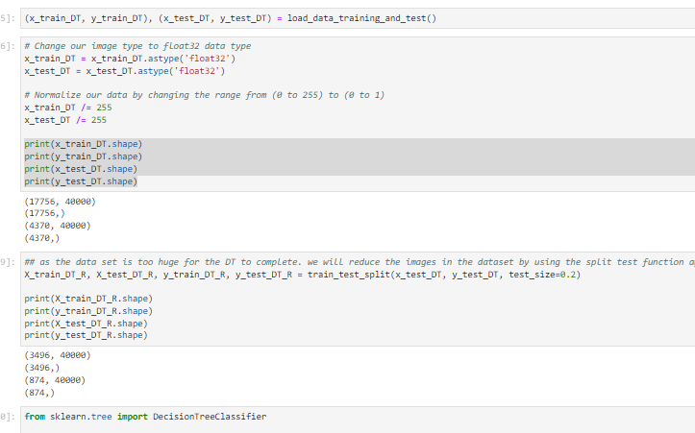

Figure 38

In this case, the train set is reduced to 3496 images while the test set is at 874 images.

Using this reduced data set, the teams proceed to train the model using decision tree algorithm.

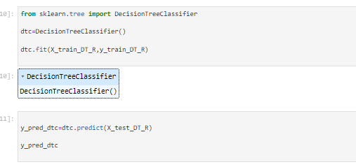

Figure 39

After training, the model is tested for accuracy.

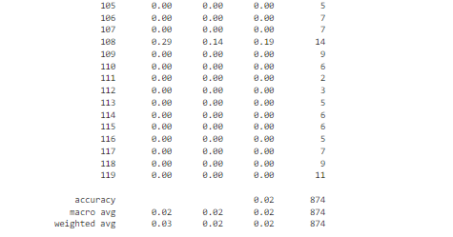

Figure 40

The accuracy of the model is at 0.02%. In view of this result, the team reviewed and concluded that we should explore other methods as this method required a huge amount of resources and time to train and test.

## Model Evaluation : Choosing CNN algorithm

Upon consolidating the results of the 3 models suggested for the recognition model, CNN model can provide the highest accuracy among the 3. However, as K Nearest Neighbour and Decision Trees are giving extremely low accuracy when training and testing with the data set. The team began a root cause analysis on the 2 algorithms to review on the cause of the poor accuracy of the K nearest neighbour and Decision Tree algorithms.

K Nearest Neighbour relies heavily on the choice of features and their representation. Images can have complex structures, textures, and patterns, in addition, it is challenging to define suitable distance metrics which can effectively identify their similarities and differences. Secondly, images contain spatial information which are important for image recognition. The algorithm does not take into account spatial relationships between the pixels in the image. Hence K nearest neighbour will have difficulties to capture the underlying structure and spatial dependencies. which causes the low accuracy in image recognition.

Decision trees are sensitive to variation in the feature values. In image recognition, pixel-based features can have variation due to lightning conditions, viewpoints or minor distortion, this causes the decreased robustness and accuracy in recognition of similar images. Furthermore, images often contain complex and nonlinear decision boundaries that separate the different classes or objects. Decision trees are limited in their ability to represent complex decision boundaries accurately.

As the team conclude the accuracy is due to the constraints on the algorithms based on our root cause analysis, the team concurred to implement the model based on the CNN model.

## Modelling Algorithm for Recommender System

Our content-based recommender system aims to provide personalized recommendations by considering the user 's choice of dog breed, apartment size, maintenance level, trainability and whether the user has a family or not. By leveraging the user’s inputs, the system will generate a list of the top 3 dog breeds that best match the owner's preferences, living conditions & lifestyle.

The recommender system consists of several components that work together to generate accurate and relevant recommendations.

By web scraping data from barkingroyalty.com, the dog breed characteristics ranking is captured in a form of a matrix containing a list of characteristics. Individual characteristics are ranked on a scale of 1 to 5, where a rating of 5 represents the highest rank and a rating of 1 represents the lowest rank for each attribute. Individual characteristics ranked from 1 to 5 score; Rating of 5 indicates highest rank while rating of 1 indicates the lowest rank in its attributes. This matrix serves as the reference for the recommendation engine to retrieve relevant information about each dog breed. The matrix structure allows for efficient storage and retrieval of breed attributes. Each row in the matrix represents a specific dog breed, and each column corresponds to a specific attribute. The attributes can include characteristics such as size, temperament, compatibility with families, and other relevant factors.

By organizing the dog breed data in a matrix format, the recommender system can easily access and compare the attributes of different breeds. The attributes within the matrix can be utilized in calculating the Euclidean distance or cosine similarity between the user's preferences and the breed attributes. This comparison enables the system to identify the dog breeds that closely match the user's preferences and living conditions.

The matrix-based dog breed database facilitates data processing and retrieval, ensuring the accuracy and reliability of the recommendations provided by the system. It allows the recommendation engine to analyze and rank the dog breeds based on their compatibility with the user's preferences, ultimately presenting the top 3 recommended breeds to the potential pet owner.

### One-Hot Encoding & Min-Max Scaling

The recommender system established one-hot encoding to represent dog breeds group & dog size as binary variables and Euclidean similarity as the metric for comparing breeds. The dataset used in the recommender system consists of a DataFrame containing dog breeds group & dog size encoded as binary variables as 1 or 0. This encoding enables consistent comparisons by standardizing the representation of categorical attributes. It ensures that no single attribute dominates the similarity calculation and allows for a level playing field in breed matching. The one-hot encoding technique captures the presence or absence of each breed, creating a comprehensive representation of the breeds in the dataset.

Min-max scaling is a normalization technique that can be used in calculating Euclidean distance similarity in a dog breed recommender system. It is a method to scale numerical features to a specific range, typically between 0 and 1. Min-max scaling ensures that each feature contributes proportionately to the Euclidean distance similarity calculation, regardless of their original scales. It allows for a fair comparison between the features and avoids any dominance of features with larger scales. By scaling the features to the range of 0-1, the Euclidean distance similarity can effectively capture the relative differences and similarities between the dog breeds across the various features.

By normalizing the features, we bring them to a consistent scale, which allows for a fairer and more meaningful comparison between dog breeds. Normalization ensures that no single feature has undue influence over the similarity calculation due to its larger scale. Instead, all features contribute proportionally to the measure of similarity, reflecting their relative importance in defining breed characteristics.

### Cosine Similarity

Cosine similarity measures the similarity between two vectors by calculating the cosine of the angle between them. It is often used to compare the orientation or direction of vectors in a multi-dimensional space. Cosine similarity ranges from -1 to 1, where a value of 1 indicates that the vectors are perfectly similar (pointing in the same direction), 0 indicates no similarity (orthogonal vectors), and -1 indicates complete dissimilarity (pointing in opposite directions).

To calculate the cosine similarity between two vectors, such as dog breeds represented as feature vectors, the following steps are typically taken:

1. Normalize the feature vectors to have a unit length. This step ensures that the magnitude or scale of the vectors does not influence the similarity calculation. It focuses solely on the orientations or directions of the vectors.
2. Compute the dot product of the normalized vectors. The dot product measures the similarity of the vectors in terms of their magnitudes and the cosine of the angle between them.
3. Divide the dot product by the product of the vector lengths to obtain the cosine similarity. This normalization step ensures that the similarity score is independent of vector lengths and only reflects the angular difference between the vectors.

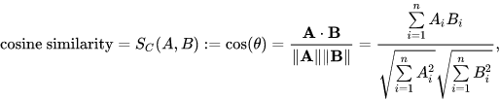

Figure 41

### Euclidean Distance Similarity

Euclidean distance is a measure of the straight-line distance between two points in a multi-dimensional space. In the recommender system, Euclidean distance can be used to quantify the similarity between the preferences of potential pet owners and the attributes of different dog breeds. By calculating the Euclidean distance between the input preferences and the characteristics of each dog breed, the system can identify breeds that are closer in terms of their attributes to the user’s input preferences.

To calculate the Euclidean distance between two vectors, such as dog breed feature vectors, the following steps are typically followed:

1. Calculate the squared differences between corresponding features of the two vectors. This step measures the magnitude of the differences between the features.
2. Sum the squared differences: Sum up all the squared differences obtained from the previous step.
3. Take the square root of the sum to obtain the Euclidean distance. This final step scales the distance back to the original feature space and provides a meaningful measure of the separation between the vectors.

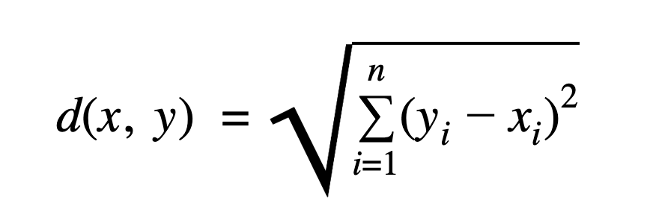

Figure 42

## Model Evaluation: Choosing Euclidean Distance

There are 4 main reasons why we choose the Euclidean Distance for our dog breed recommender system.

1. Incorporating Numerical Features:

Euclidean distance is advantageous when dealing with datasets that contain numerical features, which are often present in dog breed datasets. These numerical features, such as height, weight, or lifespan, provide valuable information for breed comparison. Euclidean distance takes into account the magnitude and differences of these numerical features, allowing for a comprehensive similarity calculation. By considering the numerical attributes, Euclidean distance enables a more accurate representation of the dissimilarities and similarities between different dog breeds.

2. Feature Importance:

In the dog breed recommender system, certain features may be more crucial than others in defining breed characteristics. Euclidean distance considers the relative importance of different features in the similarity calculation. For instance, if size-related attributes are considered critical for breed matching, Euclidean distance will capture the dissimilarities between breeds of varying sizes. By appropriately weighing the importance of different features, Euclidean distance provides a more meaningful and accurate measure of breed similarity.

3. Sensitive to Differences:

Euclidean distance is sensitive to both the magnitude and direction of differences between vectors. In the dog breed recommender system, even small differences in breed attributes can be significant. Euclidean distance captures these nuances effectively, allowing for more precise comparisons and identification of subtle differences between breeds. This sensitivity helps to highlight specific characteristics that distinguish one breed from another, providing users with more detailed and informative recommendations.

4. Explainable interpretation:

Euclidean distance provides a more intuitive interpretation of similarity. It measures the actual geometric distance between two points in the feature space. Users can easily understand and relate to the concept of distance, making it easier to comprehend the similarity between dog breeds. In contrast, cosine similarity measures the cosine of the angle between two vectors, which might be more abstract and less intuitive for users.

# Testing and Evaluation

## System Integration Testing

The team has conducted a System Integration Test to ensure the interoperability between the 2 subsystems within the MVP. The conduct of the test is as follows:

A member of the team will upload 5 photos into the system. Upon recognition of the photo, the team member will then key in random preferences into the system. Upon receiving the values, the system will provide the top 3 recommendations from the system. The success factor for this test is that the system will need to provide the top 3 recommendations for the dog breed which is being identified by the system. The member does not need to confirm if the dog breed is correctly identified. The member will need to confirm if the system displays the top 3 recommendations from the system to provide evidence that the 2 sub-systems are integrated seamlessly.

## User Acceptance Testing

Upon the completion of the system integration test, the project team proceeded to the User acceptance test. This test is to ensure the expectation of the team is met in terms of the dog breed recognition. The conduct of the test is as follows:-

Each team member will upload 10 random dog photos which they know the breed of the dog. The picture uploaded can consist of multiple objects. The team member will then record the results if the MVP is able to recognise the dog breed. The success factor of each photo will be 50% confidence in recognising the breed from the system. This will be taken as the success case. If the confidence is less than 50% then this case will be identified as a failed case. If the dog breed is not within the 120 breeds which are part of our data set, this case will be taken as an exception and will not be taken in as a valid case for the test. Team members are at their liberty to test the recommender at their own discretion and submit their findings in writing into the comments column.

## Evaluation

### System Integration Test

Cheewei has completed the test on behalf of the team and has not found any integration issues with the 2 subsystems. The System Integration Test sign off document is attached in the appendix.

### User Acceptance Test

Based on the results provided by the team, the results are consolidated and the number of pass cases is 33 out of a total of 39 valid cases. 1 of the invalid case is a picture of a corgi which is not one of the breeds that is being trained in the dataset. Hence the accuracy of the Dog breed detective based on the pass cases is **84.61%**

The UAT test excel from respective members is attached in the appendix.

# Promising Prospect, Current Shortcomings and Business Model

## Current Shortcomings

The team have recognised that there are shortcomings which reside in the system currently. However, as the shortcomings are not showstopper and the product is a Minimum Viable Product, hence the team have aligned that these constraints will be reconsidered in future iterations if opportunities permit.

### Lack of Data Set

The current data set used for the training of the algorithm consists of 120 dog breeds. However, there are 356 dog breeds that are recognised by the World Cannie Organisation(Fédération Cynologique Internationale, 2022) and this is excluding hybrid dog breeds. Hence, additional work will be required to collect data and ingest it into the system if the MVP is to be scaled up into an marketable product.

### Recognition for hybrid dog breed

Team members have concurred that the MVP have fared badly if the picture contains hybrid dog breeds based on their observation. The MVP usually provides a low confidence level in this case. The project team acknowledges the challenges associated with employing the minimum viable product (MVP) for identifying hybrid dog breeds, primarily because the genetic inheritance of the defining features of respective dog breeds is intertwined. The team will look into optimisation techniques like genetic algorithms to further explore the suitability to improve the recognition for the hybrid dog type.

8.1.3 Lack of User’s Rating Data

The absence of user rating data might affect the overall performance and effectiveness of a recommender system. User preferences allows the system to tailor recommendations to user’s lifestyle and preferences. When there is a lack of user data, the system faces challenges in terms of prediction accuracy. It struggles to deliver personalized recommendations, resulting in generic suggestions that may not align with users' specific preferences. Hence, the accuracy of the recommendations can be improved if user’s rating preferences are steadily available.

## Promising Prospect

The team has identified multiple enhancements which could bring about added value to the MVP and the pet shop business to provide higher sales/revenue returns and better customer satisfaction.

### Expanding the range of pets

Following the high success rate in the recognition of dog breeds in the MVP, the project team is confident that the same model could be applied in the same industry for other pets like rabbits/ cats This will provide a comprehensive solution for the pet business as it can cater to the majority of their customers.

### Chat bot

The team acknowledges that the implementation of a Chatbot will enable the users of the MVP to be able to describe their preferences and questions in detail. The pet business can also have a FAQ system setup to reduce their manpower cost in answering common questions which could be assisted by the chatbot. This will further add value to the functionalities of the MVP.

### Pet Related Marketplace

The MVP can add in a pet related marketplace to continue engaging the user after their enquiries or pet purchase. This will drive the sales for the pet business as well as bring about higher customer satisfaction as it provides a one stop experience for the user.

### Dog Illness Symptom Recognizer

The team analyse the possibility of adding a dog illness symptom recognizer at a high level and have concurred that it is possible to add in this recognizer using the same model for illness that exhibits external symptoms which could be identified by computer vision. This will allow the model to identify the symptoms which in turns allows the MVP to correlate to the illness closest match to these symptoms.

### Deciphering Dog Emotions

The team explored the idea of using sounds from the barks of the dogs using the hidden Markov model method or using the facial expression from the dogs in the MVP to decipher the dogs emotions. The team is confident that it is feasible however, there are multiple constraints at this moment which include the collection of data as well as expert judgement to annotate the emotions of the data.

## Business Model

The team is confident in the application's strong market potential due to the continuous upward trend in pet ownership over the past five years. In view of this, the team has suggested 2 types of pricing model if the MVP is to be scaled up. This is to provide revenue to sustain the project team to further optimize the end product as well as add in new functionalities to add value to the users of the end products.

### Free Model

The free model will enable the user to make use of the basic functions of the Application. However, the model will be driven by an ad-driven approach where pet shops or pet related products can place advertisements on the application so that their services and products could gain a higher exposure to their target audience as compared to the traditional methods of flyers and tv programs.

### Premium Model

The premium model will be ad free and will have additional functions such as illness symptoms identifier, chatbot functions to provide the users with round the clock accessibility to their needs. It will also allow more personalized recommendation based on their purchase history.

# Conclusion

The COVID-19 pandemic has caused unprecedented disruptions in the business landscape, forcing organizations to adapt rapidly to new ways of operating. As we emerge from the crisis, businesses must seek innovative solutions to enhance productivity and rebuild their operations for sustained growth. The team has produced a web application Minimum Viable Product (MVP) Dog Breed Detective which hopes to help the pet business build resilience into their business operation and aims to increase revenues and profit for the business in the long run.

The team has harnessed the knowledge acquired from the Intelligent Reasoning Course from NUS-ISS and effectively applied their learnings from the different modules spanning over a range of topics from designing a framed-based System, Similarity Recommender to Knowledge Based Reasoning System.

For this MVP, the team iterated through the different classification models (CNN,KNN and Decision Trees ) to identify the best algorithm applicable for our use cases by using the different quality assurance metrics to compare the accuracy of the different models. The team also has added additional effort to ensure that the data is normalised and apply methods like one-hot vectoring to prevent bias and inconsistency when dealing with similarity algorithms like K-nearest neighbour, Euclidean distance etc.

From the results from the user acceptance test, the system is able to recognise 80% of the dog breeds being uploaded by the members of the team. This has surpassed the expectations of the team and fulfil the success factors identified by the teams. There are breeds which are not recognised due to the lack of data sets for the breeds as well as some of the breeds are a mixture of multiple breeds which accounts for the inaccuracies.

As this is a Minimum Viable Product, the team recognise that there are limitations and improvements which can optimise and enhance the value for the business owners who wish to integrate Dog Breed Detective into their operations. If economic opportunities arise, the team will be able to conduct additional iterations to transform it into a marketable business model under the support of these economic opportunities.

As the team draws our project to a conclusion for the Dog Breed Detective temporarily, the team would like to thank our advisor and lecturers at NUS-ISS which have provided us their time and attention in guiding us through our project and the team have benefited greatly from the seamless knowledge transfer from the lecturers and the conducive environment that NUS-ISS have provided in contributing to the success of this MVP project.

# Appendix

## References

Jong Ching Yee. (2022, May 22). *Some leaving the veterinary profession in s'pore due to long hours, fatigue*. The Straits Times. Retrieved April 28, 2023, from https://www.straitstimes.com/singapore/veterinary-industry-struggles-to-retain-professionals

International Trade Administration. (2021, July 22). *Singapore Pet Products*. International Trade Administration | Trade.gov. Retrieved April 28, 2023, from https://www.trade.gov/market-intelligence/singapore-pet-products#:~:text=Pet%20ownership%20in%20Singapore%20is,reasons%20to%20adopt%20a%20pet.

Wang, Z. (2022, February 10). *Government of Canada*. Agriculture and Agri-Food Canada . Retrieved April 28, 2023, from https://agriculture.canada.ca/en/international-trade/market-intelligence/reports/sector-trend-analysis-pet-food-trends-select-cptpp-markets-vietnam-singapore-malaysia-chile-and-peru

Baheti, P. (2021, August 31). *Data preprocessing in machine learning [steps & techniques]*. Data Preprocessing in Machine Learning [Steps & Techniques]. https://www.v7labs.com/blog/data-preprocessing-guide

N, S., P, A. M., & V, H. P. (2022, June 14). *Object detection using Yolo and mobilenet SSD: A comparative study*. International Journal of Engineering Research & Technology. https://www.ijert.org/object-detection-using-yolo-and-mobilenet-ssd-a-comparative-study

Fédération Cynologique Internationale. (2022, June 21). *Presentation of Our Organisation*. Presentation of our organisation. https://www.fci.be/en/Presentation-of-our-organisation-4.html

## Project Proposal

**GRADUATE CERTIFICATE: Intelligent Reasoning Systems (IRS)**

**PRACTICE MODULE: Project Proposal**

|  |
| --- |
| **Date of proposal:**  04/03/2023 |
| **Project Title:**  The Dog Breed Detective: Solving the Mystery of your Canine Companion |
| **Sponsor/Client:** *(Name, Address, Telephone No. and Contact Name)*  Institute of Systems Science (ISS) at 25 Heng Mui Keng Terrace, Singapore  NATIONAL UNIVERSITY OF SINGAPORE (NUS)  Contact: Mr. GU ZHAN / Lecturer & Consultant  Telephone No.: 65-6516 8021  Email: [zhan.gu@nus.edu.sg](mailto:zhan.gu@nus.edu.sg) |
| **Background/Aims/Objectives:**  Newly minted canine guardians or inexperienced pet shop staff usually have trouble identifying their precious babies or understanding their daily food intake/essential information required for their wellbeing.  The project team acknowledges these pain points and would harness the use of the AI algorithm to assist these focus groups to obtain essential information necessary for their canine babies’ daily lives.  The objective of the project is to create a classifier system to correctly identify the correct breed of dogs based on the photo taken. Once the dog breed is successfully identified, the system will then apply a recommender system to provide recommendations to the focus group based on the dog breeds. |
| **Requirements Overview:**   * Research ability - Image recognition, data preprocessing, model/s training and testing * Programming ability - Frontend, backend and database * System integration ability - user interfaces and modeling |
| **Resource Requirements (please list Hardware, Software and any other resources)**  Hardware proposed for consideration:   * Local CPU   Software proposed for consideration:   * Reasoning systems, e.g. KIE jBPM, Drools, AppFormer, OptaPlanner, Fuzzy logic, Optimization, etc * Pertained machine learning models, e.g. Vision, Speech, NLP * Machine learning use cases, e.g. Orange3, R * Cognitive systems, e.g. MyCroft * Database Systems, eg sqlLite, mySQL, neo4j * Programming Language, React. Vue.js/ jQuery. |
| **Number of Learner Interns required: (Please specify their tasks if possible)**  A team of 4 project members sharing the tasks as mentioned below:-   * Data Acquisition * Data Processing, * User Interface development, * Database development * Product prototype design * Model development * Model training/hyperparameter tuning/model evaluation * Project Report |
| **Budget**  The team will be using personal laptops and software which are free to use for development and academics purposes, hence the team does not anticipate any cost associated with this project. |
| **Methods and Standards:**  The team will be using the CRISP-DM methodology for this project. The key processes identified by the team is listed in the table below:-  **A picture containing diagram, plan, circle  Description automatically generated**  **CRISP-DM image (2023 March 02) In Wikipedia** [**https://en.wikipedia.org/wiki/Cross-industry_standard_process_for_data_mining**](https://en.wikipedia.org/wiki/Cross-industry_standard_process_for_data_mining)   |  |  |  | | --- | --- | --- | | **Procedures** | **Objective** | **Key Activities** | |  | | **Business Understanding** | The team shall meet with subject matter experts(SMEs) to identify the pain points faced by the SMEs. | 1. Gather & Analyze Requirements |  | | 1. Prioritize & Consolidate Requirements |  | |  |  | | **Data Understanding** | The team will begin the data collection process and understand the data collected. This process will also investigate on the integrity and quality of the data | 1. Data Collection 2. Data Understanding 3. Analysis of Data in relation to business requirements |  | |  |  |  | | **Data Preparation** | The team will prepare and clean the data for the use in the modeling process. Outliers will also be isolated in this process.. | 1. Data Cleaning 2. Prepare the data into training data and test data 3. Prepare additional test data to further evaluate the model |  | |  |  | | **Modeling** | The project team will test out different algorithms and validate results | 1. Model Building based on business requirement understanding. 2. Model Fine Tuning |  | | **Evaluation** | Model Evaluation and selection for the business requirements |  |  | | 1. Model evaluation 2. Model selection |  | | Deployment | The team will work on the UI/UX and package the selected algorithm into a MVP for the SME. | 1. UX/UI design 2. Video creation and submission 3. Project Report Submission |  | |

**Proposed Project Timeline**

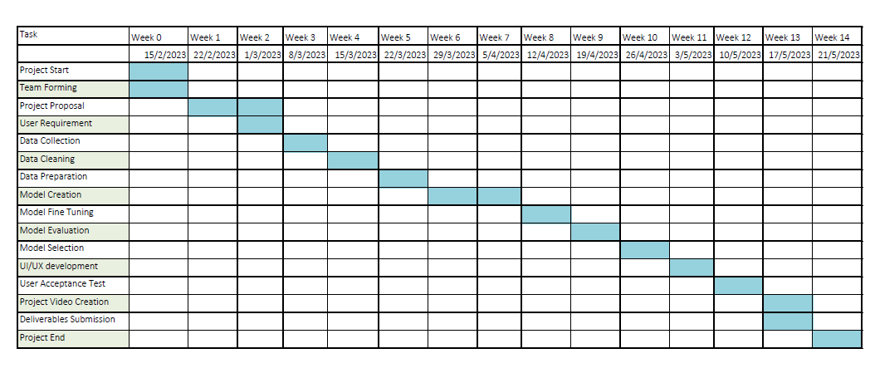

**Appendix 1:**

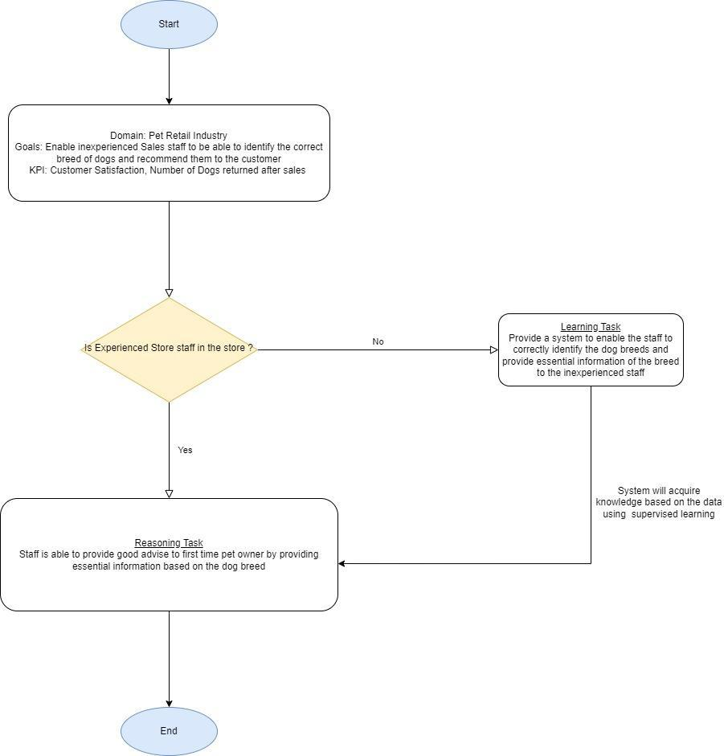

**Team Formation & Registration**

|  |
| --- |
| Team Name:  The Dog Breed Detective |
| Project Title (repeated):  The Dog Breed Detective: Solving the Mystery of your Canine Companion |
| System Name (if decided):  dogBreedDetective |
|  |
| Team Member 1 Name:  Tan Chee Wei |
| Team Member 1 Matriculation Number:  A0230818H |
| Team Member 1 Contact (Mobile/Email):  E0700584@u.nus.edu |
|  |
| Team Member 2 Name:  Aloysius Ong Jun Long |
| Team Member 2 Matriculation Number:  Stackable Certificate Student |
| Team Member 2 Contact (Mobile/Email):  Aloy31st@hotmail.com |
|  |
| Team Member 3 Name:  Goh Zhi Hui |
| Team Member 3 Matriculation Number:  A0269364R |
| Team Member 3 Contact (Mobile/Email):  e1112235@u.nus.edu |
|  |
| Team Member 4 Name:  Chen Yihan Johaness |
| Team Member 4 Matriculation Number:  A0214926A |
| Team Member 4 Contact (Mobile/Email):  e0533420@u.nus.edu |

|  |  |  |
| --- | --- | --- |
| **For ISS Use Only** | | |
| **Programme Name:** | **Project No:** | **Learner Batch:** |
| **Accepted/Rejected/KIV:** | | |
| **Learners Assigned:** | | |
| **Advisor Assigned:**  Contact: Mr. GU ZHAN / Lecturer & Consultant  Telephone No.: 65-6516 8021  Email: [zhan.gu@nus.edu.sg](mailto:zhan.gu@nus.edu.sg) | | |

## Project Objectives

|  |  |
| --- | --- |
| Objective |  |
| Decision automation: Business rules & process **OR** Knowledge based reasoning techniques | CNN Classification for the recognition of the dog breed. Evaluation of dog breed using K-nearest neighbour algorithm and decision trees. |
| Business resource optimization: Informed search **OR** Evolutionary computing techniques | Application of the Transfer Learning method to optimise the CNN training model |
| Knowledge discovery & (big) data mining techniques, e.g. recommendation; diagnosis; etc. | Dog Breed Recommendation to provide similar dog breed to the users using similarity algorithms and data mining using web scraping |
| System designed with cognitive techniques or tools, e.g. components of knowledge base: knowledge graph, frame systems, user-interface supporting human mode of communication like natural language, chat-bot, etc | Usage of Frame system for the design of the system. |

## Installation Guide

For now the application is supported only on Windows OS.

##################################################################################

Download Project Resources from GitHub

##################################################################################

Download Dog Detective from <https://github.com/swisslmp84/Dog-Breed-Detective> or alternatively Git pull

The model files are too large to be uploaded to GitHub directly and are stored with Git LFS. If you use the download zip option to download the repository, you need to download the files directly from the links below and replace them manually in your local folder after you unzip the repository:

1. <https://github.com/swisslmp84/Dog-Breed-Detective/blob/master/SystemCode/dogDetectiveProject/models/feature_extractor.h5>
2. <https://github.com/swisslmp84/Dog-Breed-Detective/blob/master/SystemCode/dogDetectiveProject/models/dogbreed.h5>

##################################################################################

Visual C++ Build Tools & Protoc

##################################################################################

1) Tensorflow relies on C++ Build Tools. Visual Studio installation is essential.

Go to <https://visualstudio.microsoft.com/vs/community/> to download the Visual Studio Installer.

2) Install "Desktop development with C++" from the Visual Studio Installer.

3) Unzip the protoc-3.14.0-win64.zip provided in the Dog-Breed-Detective project → InstallationFiles folder to a folder you prefer to store all your external libraries/packages.

4) Add protoc to your system path.

Go to System Properties --> Environment Variables --> Edit Path --> Add New --> input the path to the protoc-3.14.0-win64\bin

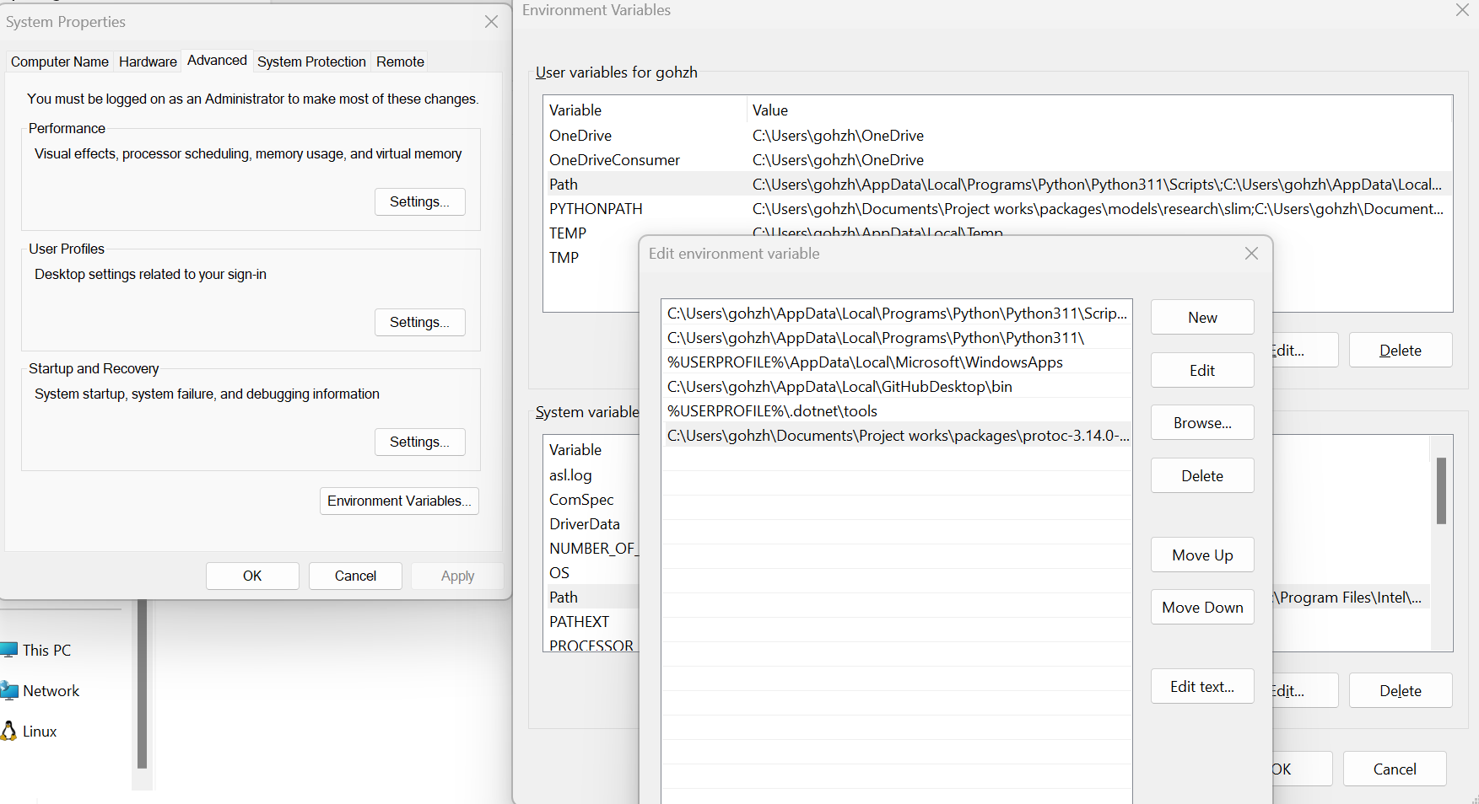

Figure 43

6) Unzip the model.zip provided in the Dog-Breed-Detective project → InstallationFiles folder to a folder you prefer to store all your external libraries/packages.

5) Add new user variables “PYTHONPATH”

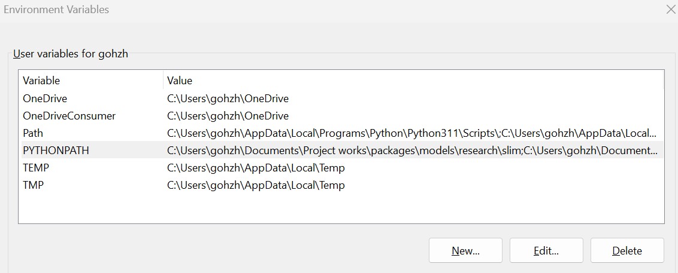

Figure 44

Add 3 values below in the “PYTHONPATH” variable, point to the directory which you have unzipped to model.zip to previously.

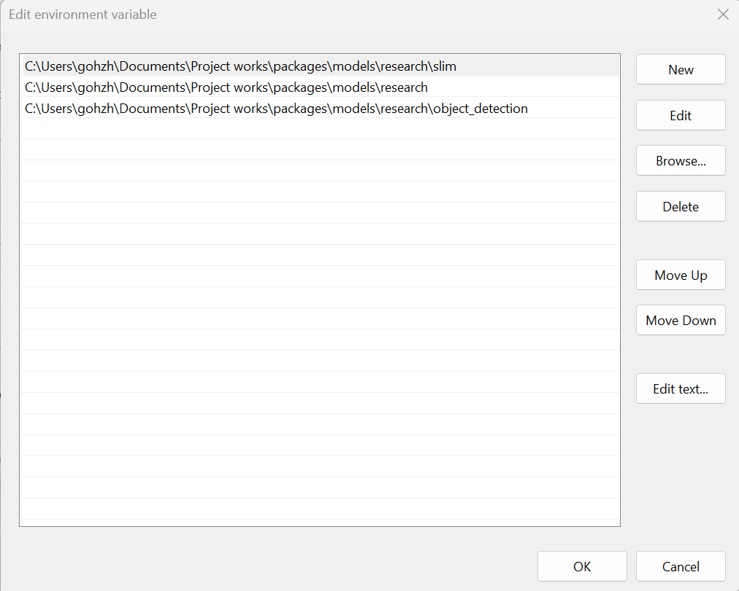

Figure 45

##################################################################################

Python & Anaconda

##################################################################################

1) This project is written in Python (backend) and uses Python libraries and flask frontend.

Python installation is essential. Python 3.9.16 & above is recommended.

Go to <https://www.python.org/downloads/windows/> to download the Python for installation

2) As we have provided an environment.yml file in the Dog-Breed-Detective project → InstallationFiles folder for sharing our package configuration, Anaconda installation is also recommended.

Go to <https://docs.anaconda.com/anaconda/install/windows/> to download installer for Anaconda

After the above 2 applications are installed

1. Open command prompt
2. Cd to the path where the environment.yml file is residing.
3. Create a new conda environment with the necessary packages for the project, execute the following command:

conda env create --file environment.yml

##################################################################################

Start Application and Test launch

##################################################################################

1. Launch Anaconda Prompt
2. Activate Conda environment using command:

conda activate dogdetective

1. Cd to the directory of the web application in the Dog-Breed-Detective project → SystemCode → dogDetectiveProject folder
2. Run the application using Anaconda Prompt command:

python webapp.py

1. Once application is running you see the below sample screenshot, you can go to <http://127.0.0.1:8080> to launch the application in browser

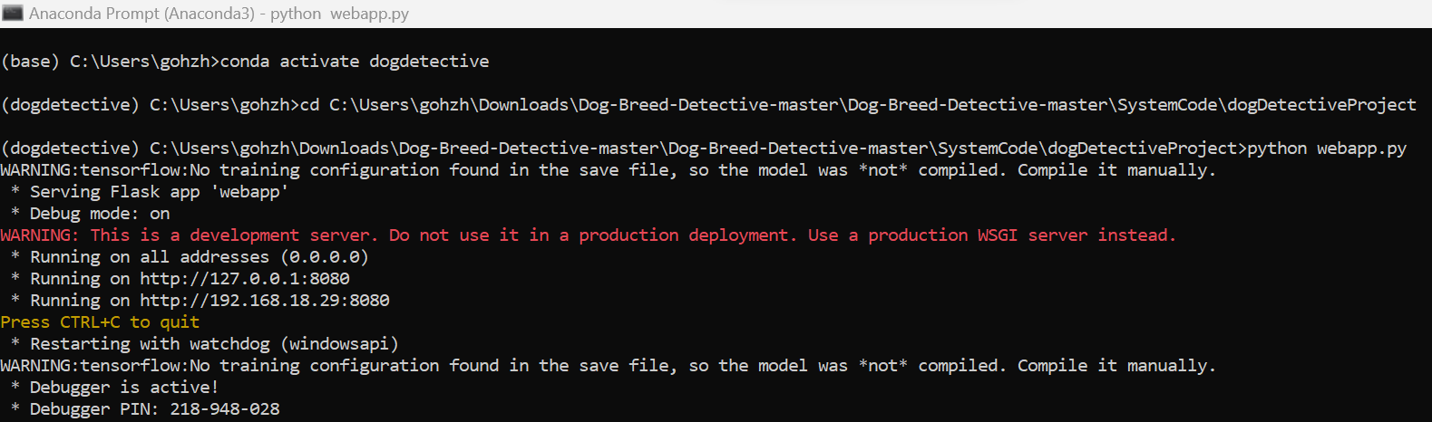

Figure 46

## User Guide

### Without Recommendation

1. User will navigate to the website of Dog Breed Detective

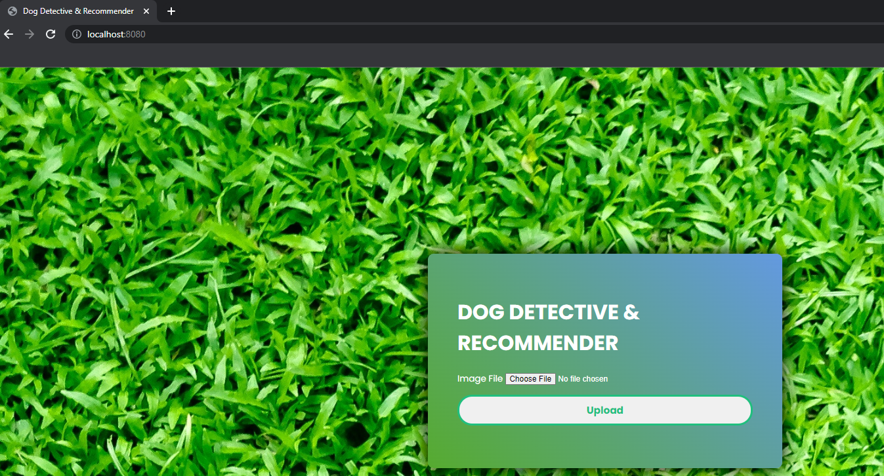

Figure 47

1. User will click on the choose file to select the picture of the dog breed the user wants to identify.

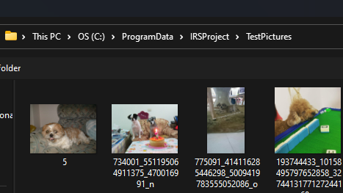

Figure 48

1. After selecting the picture, the user will be directed back to the start page. On this page, click on the upload button.

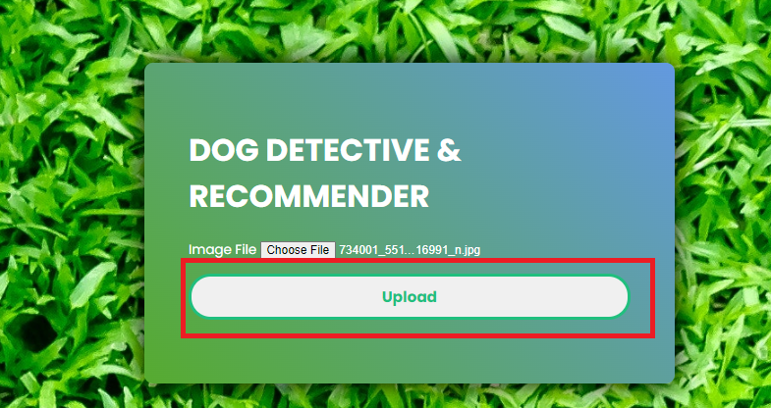

Figure 49

1. After clicking on the upload button, the system will then proceed to analyse the picture and try to identify the dog breed from the picture. It will then display the result of the picture.

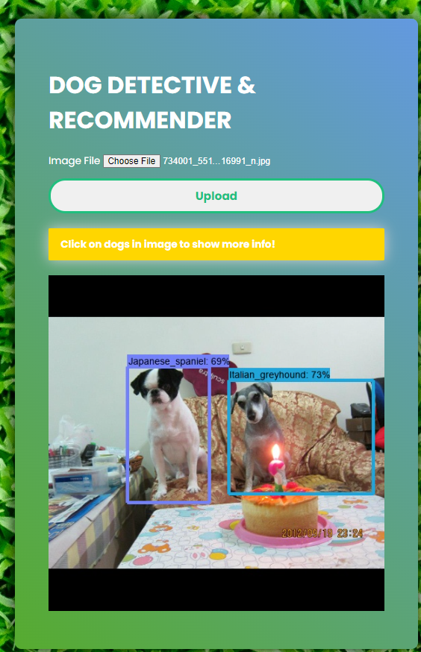

Figure 50

1. User can then click on the dog that they want to know more about and the system will display additional details for the dog for eg, a short description, apartment friendly, kids friendly

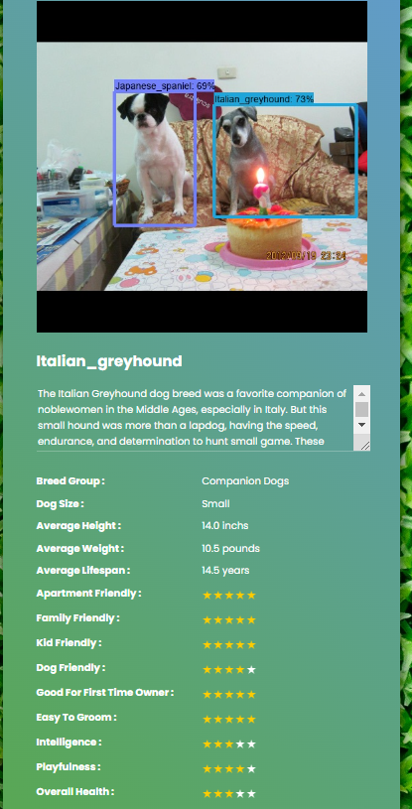

Figure 51

1. The user can then exit the system if they do not require any recommendation.

### With Recommendation

1. User will navigate to the website of Dog Breed Detective



Figure 52

1. User will click on the choose file to select the picture of the dog breed the user wants to identify.



Figure 53

1. After selecting the picture, the user will be directed back to the start page. On this page, click on the upload button.



Figure 54

1. After clicking on the upload button, the system will then proceed to analyse the picture and try to identify the dog breed from the picture. It will then display the result of the picture.

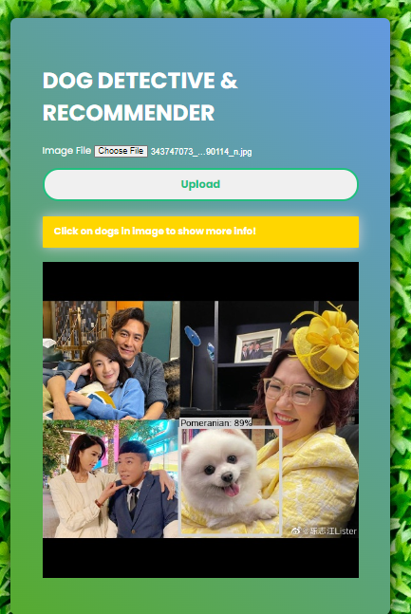

Figure 55

1. User can then click on the dog that they want to know more about and the system will display additional details for the dog for eg, a short description, apartment friendly, kids friendly

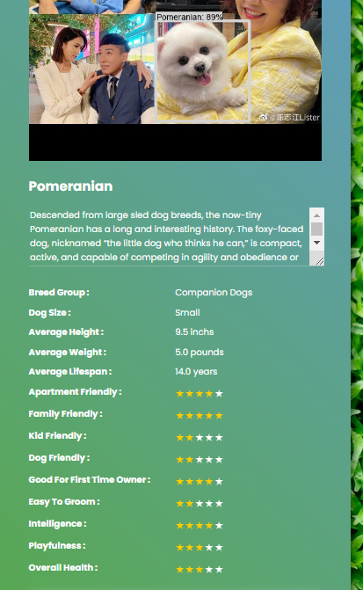

Figure 56

1. If the user requires a recommendation based on the dog breed identified, the user can navigate to the bottom part of the results.

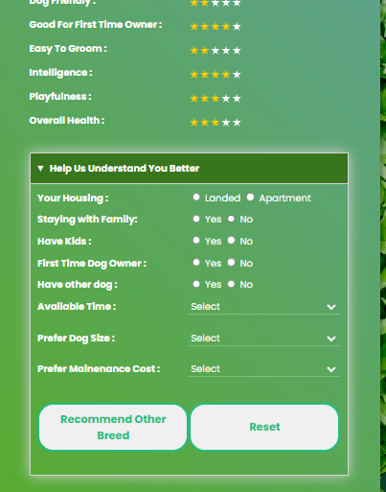

Figure 57

1. Users can then key in their preference on their current status as well as their preference in terms of maintenance cost etc.After that, user can click on the recommend other breed button

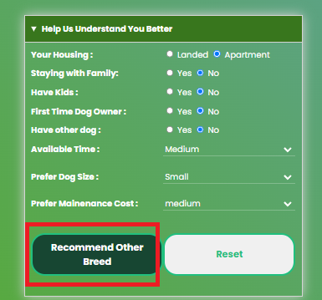

Figure 58

1. System will then recommend the top 3 dog breed based on the dog breed identified as well as the preferences they key in

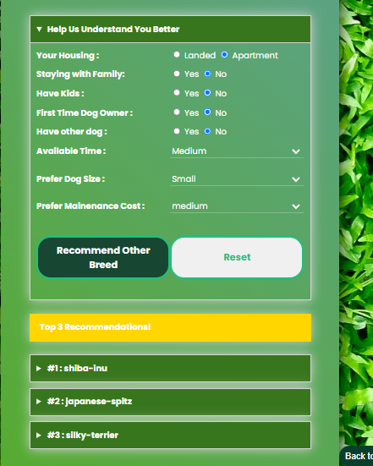

Figure 59

1. Click on the Top 3 recommended for the recommended dog breed to expand and view the breed information.

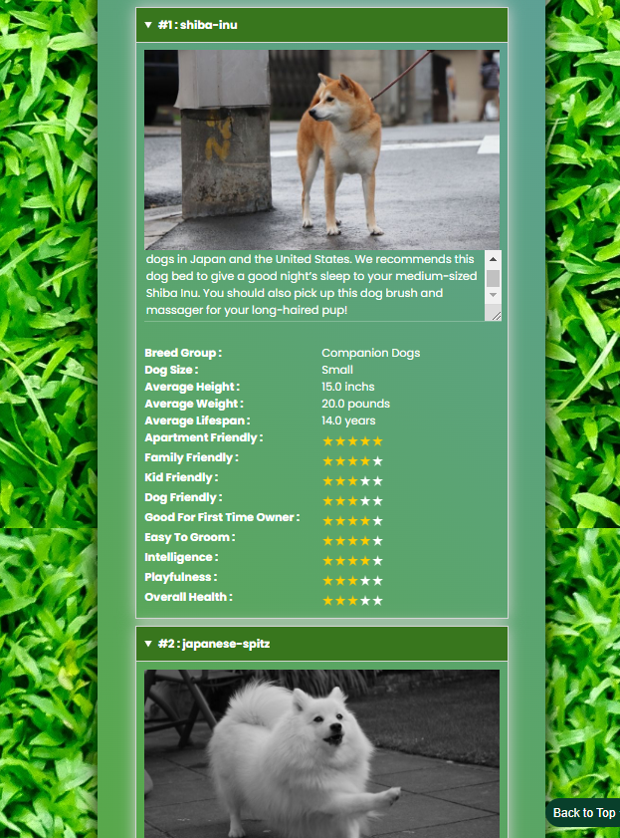

## UAT Test Results

### Goh Zhi Hui

|  |  |  |  |  |  |
| --- | --- | --- | --- | --- | --- |
| S/N | Test Case | Test Data | Expected Result | Test Result | UAT Comments |
| 1 | Uploading of chow chow dog image | chow.jpg | System should detect as chow chow | F | Detected Tibetan mastiff as 66%, recommender working |
| 2 | Uploading of 2 chow chow dog image | chowchow.jpg | System should detect as 2 chow chow dogs in the image | F | Unable to detect any dogs. |
| 3 | Uploading of cocker spaniel image | cockerspaniel.jpg | System should detect 2 dogs in the image. One is border Collie and the other is golden retriever | P | Detected cocker spaniel as 98%, recommender working |
| 4 | Uploading of Corgi image | corgi.jpg | System should detect as Corgi | NA | Corgi is not a breed being trained |
| 5 | Uploading of doberman image | doberman.jpg | System should detect as Doberman | P | Detected Doberman as 90% |
| 6 | Uploading of malamute image | malamute.jpg | System should detect as malamute | P | Detected malamute as 57% |
| 7 | Uploading of pug image | pug.jpg | System should detect as pug | P | Detected pug as 88% , recommender working |
| 8 | Uploading of pug image | pug2.jpg | System should detect as pug | P | Detected pug as 97% |
| 9 | Uploading of Tibetan mastiff image | tibetianmastiff.jpg | System should detect Tibetan mastiff | P | Detected Tibetan mastiff as 96% |
| 10 | Uploading of Tibetan mastiff image | tibettianmastif1.jpg | System should detect Tibetan mastiff | P | Detected Saint Bernard as 89% |
|  |  |  |  |  |  |
|  | |  |  |  |  |
| Test By | | Zhihui |  |  |  |
| TestDate |  | 11/05/2023 |  |  |  |
| Test Result | | 7/9 |  |  |  |

### Aloysius

|  |  |  |  |  |  |
| --- | --- | --- | --- | --- | --- |
| S/N | Test Case | Test Data | Expected Result | Test Result (Pass/Fail) | UAT Comments |
| 1 | Uploading of boxer dog image | boxer1.jpg | System should detect as boxer | P | Detected as Boxer as 60% |
| 2 | Uploading of boxer dog image | boxer2.jpg | System should detect as boxer | P | Detected as Boxer as 65% on the face. Detected a nonexistence bull mastiff in the picture. Accepted the result as Pass as it detected the boxer based on the facial features. |
| 3 | Uploading of French bulldog image | French_bulldog.jpg | System should detect as French bulldog | P | Detected French_bulldog as 88% |
| 4 | Uploading of 2 French bulldog image | Frenchbulldog2.jpg | System should detect as 2 French bulldog | F | Detected 1 French bulldog as 92% but detected another french bulldog as a pug. |
| 5 | Uploading of German shepherd image | Germanshepard1.jpg | System should detect as German shepherd | P | Detected German shepherd as 87% , recommender working |
| 6 | Uploading of German shepherd image | Germanshephard2.jpg | System should detect as German shepherd | P | Detected German shepherd as 97% |
| 7 | Uploading of Great Dane image | greatdane.jpg | System should detect as Great Dane | P | Detected Great Dane as 93% , recommender working |
| 8 | Uploading of Great Dane image | greatdane2.jpg | System should detect as Great Dane | P | Detected Great Dane as 97% , recommender working |
| 9 | Uploading of Great Dane image | greatdane3.jpg | System should detect as Great Dane | P | Detected Great Dane as 97% |
| 10 | Uploading of Samoyed image | Samoyed.jpg | System should detect Samoyed | P | Detected Samoyed as 99%, recommender working |
|  |  |  |  |  |  |
|  | |  |  |  |  |
| Test By | | Aloysius |  |  |  |
| Test Date | | 11/05/2023 |  |  |  |
| Test Result | | 9/10 |  |  |  |

### Tan Chee Wei

|  |  |  |  |  |  |
| --- | --- | --- | --- | --- | --- |
| S/N | Test Case | Test Data | Expected Result | Test Result (Pass/Fail) | UAT Comments |
| 1 | Uploading of Beagle Dog image | beagle.jpg | System should detect the image as beagle | F | Unable to detect dog |
| 2 | Uploading of border terrier Dog image | BorderTerrier.jpg | System should detect the image as border terrier | P | Detected with 94% confidence, recommender and it is working. |
| 3 | Uploading of Chihuahua image | Cheewei_chihuahu.jpg | System should detect the image as chihuahua | P | detected with 98% confidence |
| 4 | Uploading of Chihuahua image | chihuahu2.jpg | System should detect the image as chihuahua | P | detected with 88% confidence |
| 5 | Uploading of shin tzu image | Cheewei_Shihtzu1.jpg | System should detect the image as shih tzu | P | detected with 88% confidence |
| 6 | Uploading of Beagle Dog image | GoldenRetriver.jpg | System should detect the image as golden retriever | P | detected with 77% confidence |
| 7 | Uploading of Beagle Dog image | malionis.jpg | System should detect the image as Malinois | P | detected with 98% confidence, recommender and it is working |
| 8 | Uploading of Beagle Dog image | poodle.jpg | System should detect the image as poodle | F | detected as Irish water spaniel with 56% |
| 9 | Uploading of Pomeranian image | promei.jpg | System should detect the image as Pomeranian | P | detected Pomeranian 89% confidence |
| 10 | Uploading of rottweiler image | rottweiler.jpg | System should detect the image as rottweiler | P | detected rottweiler with 98% confidence |
|  |  |  |  |  |  |
|  |  |  |  |  |  |
| Test By | | Chee Wei |  |  |  |
| Test Date | | 12/05/2023 |  |  |  |
| Test Result | | 8/10 |  |  |  |

### Chen Yihan Johaness

|  |  |  |  |  |  |
| --- | --- | --- | --- | --- | --- |
| S/N | Test Case | Test Data | Expected Result | Test Result (Pass/Fail) | UAT Comments |
| 1 | Uploading of Bernese Mountain dog and Saint Bernard image | bernemountainandsaintbernad.jpg | System should detect 2 dogs in the image. One is Bernese mountain dog and the other is Saint Bernard | P | Detected Saint Bernard as 99% and Bernese Mountain dog as 93% |
| 2 | Uploading of border Collie and German shepherd Dog | Borderandgermanshpe.jpg | System should detect 2 dogs in the image. border Collie and German shepherd | F | Detected Border Collie as 26% and Leonberg 52% |
| 3 | Uploading of Border Collie and Golden Retriever image | borderandgolderretriver.jpg | System should detect 2 dogs in the image. One is border Collie and the other is golden retriever | P | Detected Border Collie as 94% and Golden Retriever as 94% |
| 4 | Uploading of border collie image | bordercollie1.jpg | System should detect as border collie | P | Detected Border Collie as 92% |
| 5 | Uploading of border collie image | bordercollie2.jpg | System should detect as border collie | P | Detected Border Collie as 87% |
| 6 | Uploading of border collie image | bordercollie3.jpg | System should detect as border collie | P | Detected Border Collie as 88% |
| 7 | Uploading of English setter image | englishsetter.jpg | System should detect as English setter | P | Detected English setter as 100% |
| 8 | Uploading of Old English sheepdog image | oldenglishsheepdog.jpg | System should detect as Old English sheepdog | P | Detected Old English sheepdog as 97% |
| 9 | Uploading of Saint Bernard image | saintbernad1.jpg | System should detect Saint Bernard | P | Detected Saint Bernard as 96% |
| 10 | Uploading of Saint Bernard image | saintbernad2.jpg | System should detect Saint Bernard | P | Detected Saint Bernard as 84% |
|  |  |  |  |  |  |
|  |  |  |  |  |  |
| Test By | | Joe |  |  |  |
| TestDate |  | 12/05/2023 |  |  |  |
| Test Result | | 9/10 |  |  |  |

## Team Member Reports

### Goh Zhi Hui

|  |  |  |  |
| --- | --- | --- | --- |
| **Name:** | Goh Zhi Hui | **ID:** | A0269364R |
| **Personal Contribution:** | | | |
| I worked on analysing the image dataset and did the data pre-processing for images. Experiment and train the CNN model for image classification. From a coding perspective, I developed the image recognition sub-system on the object detection and image classification functions. I am involved in coding the backend APIs for integration to the frontend logic. I also helped in the frontend design and coding.  I contributed to the report for installation guide, data pre-processing for images and CNN modelling.  I have also participated in the UAT to ensure that the system meets our requirements. | | | |
| **Learning Journey and Outcome:** | | | |
| My learnings:  1. Computer vision in image recognition: Understanding what images are and how the image can be seen digitally. The storage of images in multidimensional arrays.  Learn some skills in manipulating images like resizing, cropping, converting colour images into grayscale images which is essential to perform the data pre-processing.  Understand object localization and detection and study on how to implement object detection using a pre-trained model.  Learn neural network in machine learning and explore working with convolution neural network which further lead me to discover transfer learning and feature extraction techniques which I used to train up the image classification model.  2. Machine learning: Supervised learning to train a CNN model for image classification and how to interpret the validation result using confusion matrix and graphs.  3. Application Development: Strengthen my coding in Python Language and web application integration using APIs.  4. Technologies: In this project, I have learned how to use Python to build interactive frontend and backend application using Python Flask. I also gain knowledge on using OpenCV and TensorFlow libraries for developing the image recognition sub-system. | | | |
| **Application of Knowledge:** | | | |
| Image recognition can be applied in many areas. Text recognition is one area that is pretty similar to what is done in this project. Reapplying the knowledge to build a text recognition system to capture hard copy forms information into digital copy will help to remove mundane work like data entry tasks in my company. | | | |

### Aloysius Ong Jun Long

|  |  |  |  |
| --- | --- | --- | --- |
| **Name:** | Aloysius Ong Jun Long | **ID:** | S****0702J |
| **Personal Contribution:** | | | |
| I contributed to recommender systems, knowledge acquisition and data processing using web scraping tools such as Beautiful Soup to gather and organize dog breed characteristics data.  I utilized web scraping and processing techniques with Beautiful Soup to acquire and process dog breed characteristics data. I designed and implemented web scraping scripts to extract relevant information from www.barkingroyalty.com. Using Beautiful Soup's powerful parsing capabilities, I efficiently navigated and extracted the required data, including physical attributes, temperament, sociability, maintenance level, and other essential characteristics of different dog breeds. I processed and organized this data into an item matrix, ensuring its accuracy and consistency when processing the recommender system.  I have also participated in the UAT to ensure the system meets our SuccessFactors. | | | |
| **Learning Journey and Outcome:** | | | |
| I acquired knowledge in creating a knowledge base, consolidating verified dog breed information from multiple sources. By leveraging our machine reasoning skills, I developed an understanding of how to incorporate logical inference and reasoning capabilities into the system, enabling it to provide more robust and intelligent recommendations, utilizing web scraping techniques with Beautiful Soup for data acquisition and processing, and integrating a knowledge base with machine reasoning capabilities. This allows a recommender system by enabling end users to make informed decisions based on the dog breed characteristics data and the knowledge base. This project experience has not only enhanced my technical capabilities but has also deepened my understanding of recommender system models, and the integration of knowledge bases with machine reasoning. | | | |
| **Application of Knowledge:** | | | |
| As a Data Analyst, the skill that I acquired from this project allow me to build recommender system, acquire data and applying cosine similarity, Euclidean distance & other recommender algorithm to find matching patterns and predict the user’s preference. | | | |

### Chen Yihan Johaness

|  |  |  |  |
| --- | --- | --- | --- |
| **Name:** | Chen Yihan Johaness | **ID:** | A0214926A |
| **Personal Contribution:** | | | |
| I contributed to project discussions and provided consultancy to the team in terms of business and market models. I am involved with the business and market research and act as a Subject Matter Expert for the team with regards to business and market trends. I participated in the UAT for the system and created the technical video and the promotion video for the project  I developed frontend application by coding in html/javascript/css. | | | |
| **Learning Journey and Outcome:** | | | |
| It was an interesting and enriching journey working with the team from ideation to execution and finally arriving at the final product.  The team strongly believes that there is market potential for our concept and that there could be further enhancements and additional features such as dog emotion recognizer (from their bark or facial expression) or dog illness symptom checker.  Through this project, the team was exposed to different machine learning tools and had the opportunity to develop a working prototype utilising these tools. | | | |
| **Application of Knowledge:** | | | |
| The CNN, Decision Tree and KNN types of machine learning models can be applied to all kinds of data, not just for image recognition.  I look forward to exploring these for other types of data in the course and also in my occupational work. | | | |

### Tan Chee Wei

|  |  |  |  |
| --- | --- | --- | --- |
| **Name:** | Tan Chee Wei | **ID:** | A0230818H |
| **Personal Contribution:** | | | |
| My contribution to the team is managing the project and ensuring that the deliverables are submitted within the timeline. I have ensured that the project documentation is updated as the project progresses. I have contributed to the data acquisition for the dog dataset. I have conducted System Integration Testing and participated in the User acceptance Testing as mandated in the Proposal approach and Timeline.  My contribution to the model building is by experimenting with the K Nearest neighbour algorithm and the decision tree algorithm to validate its value and suitability in our project.  I have contributed to the report by consolidating the inputs from the team and formatting them into the project report. | | | |
| **Learning Journey and Outcome:** | | | |
| The learning journey has been an enriching one. As my team consists of programmers and data analysts, the exchange of knowledge from their domain have been empowering and I feel that I have learnt to look from their perspective which have given me new insights in managing an AI modelling project.  The transfer of knowledge from this course has also deepened my understanding of reasoning systems as well as exposure to common use algorithms like the decision trees, K nearest neighbour, Market Basket Analysis etc. I also have strengthened in my ability in coding in python and am now able to make use of it to train multiple commonly used algorithms. | | | |
| **Application of Knowledge:** | | | |
| As a project manager, I can make use of the new insights from my teammates during this project to manage future AI projects better. This will allow me to understand their pain points and enable me to provide a more suitable timeline and budget for future AI projects. The knowledge I gained from the Graduate Certificate of Intelligent Reason System enabled me to understand the advantages and constraints of the different algorithms and reasoning systems and allow me to provide informed choices to my stakeholders which in turn add value to my project management task. | | | |